**Nesma & Partners Leadership Development Program (LDP)**

**Comprehensive Pilot Report & Strategic Enablement Plan**

An in-depth report covering key deliverables, tools, insights, and the strategic roadmap IVY & Company will provide to support the successful rollout of the LDP at Nesma & Partners.

Prepared by Ivy & Company on 24th April, 2025

# 

# Introduction: Scope Evolution and Value Additions

Throughout the course of the Leadership Development Program, IVY & Company identified three key challenges posed by Nesma & Partners, which form the core objectives of this study:

1. *Are our leaders currently in the right roles based on their behavioral and leadership profiles?* This objective centers on identifying optimal leadership placement and uncovering potential misalignments across the organization.
2. *What leadership and interpersonal skills are missing or underdeveloped?* This focuses on mapping current competencies against the capabilities required by position and function.
3. *What clear, strategic roadmap should HR follow to address these gaps and ensure future readiness?*  This objective is met by creating actionable development strategies tailored to both individual and organizational needs.

To address these strategic questions, a detailed project plan was agreed upon to outline the core phases of assessment, analysis, and reporting at the start of the Leadership Development Program (LDP). Over the course of implementation, **we significantly enhanced and expanded the original scope**. The engagement was restructured into three strategic parts—**Preparation & Setup, Exercise & Build, and Analysis & Way Forward**—with additional phases introduced to deepen insight, personalization, and long-term impact.

As part of these enhancements, **we replaced static PDF reports with live dashboards**, enabling real-time visibility into individual and cohort-level performance, skill gaps, and behavioral trends. In parallel, **we developed a standalone analytical tool** for benchmarking and comparative analysis—allowing HR and leadership to conduct cross-functional evaluations, identify talent patterns, and support data-driven decision-making. This tool, originally out of scope, added a critical layer of strategic intelligence to the program.

To further elevate insight, **we introduced a suite of leadership metrics**, including the **Leadership Index Score (LIS)** and the proprietary **Leadership DNA (LDNA)**—a composite diagnostic that maps each leader’s behavioral fingerprint across emotional intelligence, soft skills, and leadership styles. These tools formed the analytical backbone of the program, allowing us to generate highly tailored development plans, mentorship pipelines, and succession insights across the organization.

| **Original Phase In The Contract** | **Revised Phase Name** |
| --- | --- |
| Launch Program (Preparation Phase): | ***Part 1: Preparation & Setup*** |
| Phase 0: Job Description Analysis | Phase 0: Inception and Mobilization |
| Phase 1: Skill Identification & Categorization | Phase 1: Job Description Analysis |
| Phase 2: Stakeholder Feedback on Skills | Phase 2: Skill Identification & Categorization |
| Phase 3: Dashboard Creation per Job Description | Phase 3: Dashboard Creation per Job Description |
| Phase 4: Manager Self-Assessment | Phase 4: Stakeholder Feedback & Validation |
| Phase 5: Assessment and Individual Dashboard Development | ***Part 2: Activation & Deployment*** |
| Phase 6: Gap Analysis and Training Action Plan | Phase 5: Communication Plan Kickoff |
| Phase 7: Group Report and Action Plan( Including recommendations) | Phase 6: Discovery-Tools Launch |
|  | Phase 7: Personal Development Plan Methodology |
|  | ***Part 3: Findings & Forward Strategy*** |
|  | Phase 8: Insights & Findings Analysis |
|  | Phase 9: Answering Our 3 Fundamental Questions |
|  | Phase 10: Key Learning Points & Way Forward |
|  | Phase 11: HR Toolkit Implementation |

## Out-of-Scope Additions to Improve the Program and Optimize Output

In addition to the original scope, IVY & Company introduced several enhancements aimed at optimizing program execution and deepening strategic impact. These out-of-scope additions were designed to improve diagnostic precision, elevate the participant experience, and strengthen the program’s long-term value as a leadership development and organizational planning tool.

1. **Methodology and Content Innovation**

**a. New Metrics and Indicators**

*Leadership Index Score (LIS)*

A composite readiness score combining emotional intelligence, behavioral skills, and leadership typology. The LIS provides a single, standardized metric to assess whether a leader has the leadership skills required for their role. It helps HR quickly identify high performers, outliers, and developmental priorities.

*Development of LDNA (Leadership DNA) Framework*

To extend the value of the discovery tool data, IVY developed a proprietary Leadership DNA (LDNA) framework—an organizational-level behavioral index designed to map collective leadership strengths, gaps, and alignment with strategic values. Rather than serving solely as a summary model, the LDNA is positioned as a scalable diagnostic framework that can inform future talent calibration, leadership succession planning, and workforce strategy.

For more information on LDNA, please refer to Phase 8: LDNA.

*Engagement Calculator to Track Participation Behaviorally*

An Engagement Calculator was created to measure leaders’ participation in the program using behavioral inputs such as workshop completion, response time, proactive communication, and escalation events. This tool generated a normalized engagement score used for cohort segmentation and mentoring readiness.

For more information on the Engagement Calculator, please refer to Phase 8.2.2: Engagement Calculator.

*Personalized Training Archetypes and Group Training Maps*

To streamline learning strategy, leaders were grouped by development archetype (e.g., “Advanced EQ, Beginner Communication”) with recommended tracks for targeted training. This allowed for efficient program design at both the individual and group levels.

For more information on the Training Archetypes and Group Training Maps, please refer to Appendix Report D3.

**b. New Mentor Identification Method**

*Mentor Pool Selection and Readiness Analysis*

Beyond performance scoring, we built a logic-based analysis to identify high-LIS, high-EQ leaders with mentoring leadership styles. These individuals were flagged as peer mentorship candidates, forming the foundation of a future mentorship initiative.

For more information on the Mentor Pool Selection, please refer to Phase 8.4.5: Organizational Level Intervention - Mentorship Program Integration.

*Mentorship Matching Infrastructure*

A backend logic structure was developed to facilitate future mentor-mentee matching, factoring in leadership style compatibility, skill gaps, engagement, and role function. This system can enable scalable, data-informed mentorship deployment in future cohorts.

For more information on the Mentorship Matching, please refer to Appendix Report D4.

1. **Technology Integration and Advanced Data Analytics**

*Real-Time Dashboards*

Transitioned from static PDFs to interactive, real-time dashboards that deliver instant performance insights, enhance user experience, and simplify report access. Customized dashboards were created for each leader and for cohort-wide monitoring, visualizing key metrics such as LIS, skill gaps, development plans, and engagement behavior—empowering both HR and leaders to transparently track progress and drive continuous improvement.

*AI-Powered Leadership Competency Viewer*

A state-of-the-art, standalone benchmarking tool—originally outside the project scope—that added significant strategic value. The Leadership Competency Viewer is an intelligent analytics platform that integrates data visualization, strategic filtering, and an AI-powered assistant. It empowers HR and leadership teams to explore insights on demand, ask natural language questions (e.g., “Which leaders need EQ training?”), and receive instant, auto-generated summaries and comparisons—all without needing technical expertise.

*Visual Identity and Language Refinements Based on HR Feedback*

In response to communications feedback, IVY revised dashboard and platform language (e.g., replacing “assessment” with “discovery tool”) and adjusted layout design elements to enhance clarity, reduce perceived formality, and align with internal tone-of-voice expectations.

For more information on the Language Refinements, please refer to Phase 4.4 Terminology Standardization..

# Executive Summary

**Program Objective**

As aforementioned, this program was designed to answer three critical questions posed by Nesma & Partners:

1. **Are our leaders currently in the right roles based on their behavioral and leadership profiles?** This objective focuses on assessing role alignment using a combination of behavioral and organizational metrics, including the Leadership DNA (LDNA) framework, Leadership Index Score (LIS), Emotional Intelligence (EQ), and Leadership Typology.
2. **What leadership and interpersonal skills are missing or underdeveloped?** Skill gaps are diagnosed through each leader’s average skill score and identified development areas, with insights drawn from both the frequency and severity of these gaps.
3. **What clear, strategic roadmap should HR follow to address these gaps and enable future readiness?**
4. A targeted development strategy is established through Training Load tiers (Beginner, Intermediate, Advanced), allowing precise and phased interventions tailored to each leader’s specific growth stage.

**Program Overview**

The pilot Leadership Development Program (LDP) engaged 100 leaders through a fully virtual, modular model featuring role-based customization, job-function dashboards, discovery assessments (MANSSA and MEIQ), a self-paced workshop, and personalized development plans—standardized by job cluster to ensure relevance and comparability.

The methodology emphasized standardization within job clusters to enable apples-to-apples comparisons and ensure relevance of assessed competencies.

**High-Level Results**

* **86% of leaders fit Strongly or Very Strongly within their roles.** Based on the Leadership Index Score (LIS)—a composite metric combining emotional intelligence, leadership style, and behavioral skills—85% of leaders demonstrated strong alignment with the requirements of their current positions.
* **Average Leadership Index Score (LIS) is 78%** This score measures a leader’s fit for their role by combining emotional intelligence and all job-relevant skills. The average LIS confirms that the majority of leaders are behaviorally equipped for their roles.
* **96% Of Leaders are recommended training in EQ,** while the other most frequently flagged development areas include Communication, and Accountability.
* **Mentorship potential: 35% of leaders identified as 'Mentoring Leaders'.** These individuals scored highest leadership indexes and possess leadership styles ideal for supporting others—providing a strong base for peer mentorship programs.
* **Average Emotional Intelligence (EQ) is 71%** indicates moderate-to-strong interpersonal awareness and regulation.EQ was assessed across four core dimensions and plays a critical role in communication, empathy, and adaptability.
* **Top skill gaps are Emotional Self-Awareness, Accountability, Communication.** These were the most frequently flagged development areas, suggesting the need for further training in interpersonal clarity, ownership, and self-regulation.

**Upskilling and Development Strategy**

While our analysis confirms most leaders fit their roles, we've identified skill development opportunities at four levels, delivering a multi-tiered response to address developmental gaps:

1. **Organizational Level:** Promote LDP to foster targeted development and solidify a culture of mentorship as part of strategic leadership development.
2. **HR Level:** Targeted training programs and structure mentor-mentee initiatives.
3. **Line Manager Level:** Comprehensive reports and coaching frameworks for supervisors to guide their teams through development.
4. **Individual Leader Level:** Enable self-driven growth through curated Personal Development Plans (PDPs) embedded in each dashboard.

### 

### Outline

1. **Introduction: Scope Evolution & Value Additions**
2. **Executive Summary**
3. **Program Structure: Original vs. Enhanced Phases**
4. **Part 1: Preparation & Setup**
   * Phase 0: Inception & Mobilization
   * Phase 1: Job Description Analysis
   * Phase 2: Skill Identification & Categorization
   * Phase 3: Building Leadership Dashboards (D1-D13)
   * Phase 4: Stakeholder Feedback & Validation
5. **Part 2: Activation & Deployment**
   * Phase 5: Communication Plan Kick-off
   * Phase 6: Discovery-Tools Launch
   * Phase 7: Personal Development Plan Methodology
6. **Part 3: Findings & Forward Strategy**
   * Phase 8: Insights & Findings Analysis
   * Phase 9: Answering Our 3 Fundamental Questions
   * Phase 10: Key Learning Points & Way Forward
   * Phase 11: HR Toolkit Implementation

# 

# Part 1: Preparation & Setup

## Phase 0: Inception and Mobilization

The Leadership Development Program (LDP) formally commenced on **18/09/2024** with a structured mobilization process between Nesma & Partners and IVY & Company. This foundational phase established the program's core objectives, governance framework, and operating model—ensuring clarity, alignment, and accountability across all stakeholders before execution.

### 0.1 Clear Program Objectives of the LDP

* Assess leadership capability across soft skills and emotional intelligence
* Determine role alignment using behavioral diagnostics
* Generate data-driven personal development plans (PDPs)
* Equip HR with strategic tools for talent development and succession planning
* Create long-term value through mentoring, training, and engagement initiatives

### 0.2 Solid Governance Structure

The program was jointly governed through a collaborative structure comprising:

#### 0.2.1 Client Team:

* **Client Sponsor:** Housam Ibrahimbasha, Head of HR
* **Client Leads:** Amani Al Ali (Senior Lead), Abrar Alzubail (Project Manager)
* **Client Specialists:** Salam Aljishi (Director of Corporate Communications & CSR), Karim Jazzar (HR Director)

#### **0.2.2 IVY Project Team**:

* **Gaelle Bou Abdo** – **Senior Partner-in-Charge:** Provides overall strategic direction, ensures delivery excellence, and serves as the executive sponsor for the engagement. Acts as the primary escalation point for the client and drives long-term value creation.
* **Prof. Paris de L’Etraz** – **Senior Partner – Strategic Advisor:** Brings deep thought leadership and innovation expertise. Advises on high-level frameworks, executive alignment, and strategic decision-making throughout the project lifecycle.
* **Trinity Wildenstein** – **Project Manager:** Responsible for day-to-day project coordination, milestone delivery, and team orchestration. Serves as the central point of contact for operational updates and implementation logistics.
* **Haleema Aboulenein & Lola Tohme** – **HR Specialists:** Support content development, dashboard interpretation, and talent insights. Collaborate closely with the client’s HR team to align tools and outputs with organizational needs.
* **Omar Harradi** – **Data/Tech Specialist:** Designed and implemented the full technical architecture of the LDP, including data processing, dashboard automation, and development of the AI-powered Leadership Competency Viewer.
* **Andrés Gigena** – **HR Consultant:** Provides technical input on HR models, supports benchmarking, and advises on the development of personal development plans and organizational capability frameworks.

### 0.3 Ways of Working

* **Co-development Model**: Tools, dashboards, and communications were designed iteratively with feedback loops from Nesma’s HR and Communications teams.
* **Secure File Sharing**: A centralized folder system was used to manage all deliverables, status trackers, and communication assets.
* **Agile Adjustments**: Timeline flexibility was built in to accommodate evolving needs, such as the shift from live workshops to asynchronous video delivery.
* **Weekly Progress Updates**: A structured cadence of progress tracking and reporting ensures transparency and timely stakeholder engagement.

### 0.4 Kickoff Meeting

**Kickoff Meeting and Communication Plan Proposal:** Held on September 18, 2024, the kickoff meeting was used to formally initiate the LDP engagement and propose the “[LDP Deployment & Communication Plan](https://drive.google.com/file/d/1ATZp0PkJMPG5GrDxnM8pAevIx6VY1dvW/view?usp=drive_link)” detailing:

* The structure and content of the planned workshop structure
* A sequence of communications, including CEO endorsement and HR onboarding emails
* Milestones for workshop viewing, discovery-tool completion, and dashboard issuance

The plan was reviewed by Nesma’s HR and Communication leadership and validated with minor revisions. Based on Nesma’s request to accommodate all 100 participants, the live workshops were replaced with a pre-recorded video format. This final version of the LDP Workshop is covered in **Part 2:** **Phase 5.2**.

Early alignment during this kickoff ensured the program approach reflected internal dynamics and leadership sensitivities, securing stakeholder buy-in from the outset.

Decision-making and issue resolution were handled regularly through bi-weekly alignment meetings and transitioning to milestone-based reviews.

## 

## Phase 1: Job Description Analysis

The first step in developing a tailored leadership evaluation approach was the analysis of job descriptions to define the final 13 types of dashboards. This ensured that all subsequent evaluations were standardized and role-relevant allowing comparisons between groups.

### 1.1 Collection and Review of Job Descriptions

The program began with the collection of [job descriptions](https://drive.google.com/drive/folders/1i0PyD4y2vY1_xjPfeT9oEWuY-Gs-LgxK?usp=sharing) from 100 Leaders across Nesma & Partners, compiled by the HR team into a shared folder. These roles spanned departments such as Engineering, Finance, HSSE, Strategy, and Communications. Each job description was reviewed to confirm clarity, current relevance, and completeness.

### 1.2 Functional Role Mapping

Roles were classified using a two-axis framework:

* **Functional Domain** – e.g., Engineering, Finance, HSSE, Operations
* **Leadership Level** – e.g., Executive, Line Manager, Leader

This classification allowed for the clustering of similar roles into functional groupings with comparable behavioral expectations and leadership responsibilities.

### 1.3 Dashboard Grouping and Clustering

Using the above classifications, the roles were grouped into 13 types of dashboards, each representing a unique leadership cluster with similar functional responsibilities and leadership skills.

This clustering, now referred to as the “[LDP Job Function Tree](https://drive.google.com/file/d/1dp42rMdEDALFTEd0qYKpYQmjl1QHbicm/view?usp=sharing)” formed the foundation for all comparative analysis, enabling standardized benchmarking across similar job roles (i.e., “apples-to-apples” comparison).

## 

## Phase 2: Skill Identification & Categorization

Having the 13 dashboard types defined, the next step was to design the skill profile for each cluster. This phase focused on identifying the most relevant behavioral and interpersonal competencies for each leadership group.

### 

### 2.1 Soft Skill Library Development

A repository of **52 validated soft skills** was used as the baseline for evaluation. These skills reflected behavioral competencies commonly linked to leadership success and included areas such as:

* Strategic Thinking
* Communication
* Emotional Regulation
* Conflict Management
* Delegation
* Decision-Making

**Emotional Intelligence (EQ)** was modeled separately and treated as a standalone domain critical to all roles.

### 2.2 Skill Tiering Framework

For each dashboard type, approximately 15 skills were selected and assigned across three performance pools:

* **Key Skills:** Weighted highest in scoring, these skills were deemed mission-critical to success in the role. They often involved strategic leadership, communication under pressure, and problem-solving.
* **Useful Skills:** Mapped to operational and team efficiency. They support daily task execution, such as delegation, organization, or feedback delivery.
* **Supplemental Skills:** Skills that increase adaptability and leadership range but are not essential to baseline performance-e.g., charisma, patience, or recruitment.

These tiers were defined using a standardized logic:

**Table 1: Skill Tier Logic and Threshold**

| **Skill Tier** | **Role Relevance** | **Threshold** |
| --- | --- | --- |
| Key | Mission-critical, weighted highest | ≥ 85% |
| Useful | Support daily execution | ≥ 70% |
| Supplemental | Increase adaptability | ≥ 60% |

Skill selection per dashboard was based on:

* **Functional frequency** (job description language and day-to-day relevance)
* **Strategic weight** (impact on business outcomes)
* **Hierarchical relevance** (e.g., EQ is Key in stakeholder-facing roles)

## 

## Phase 3: Building Leadership Dashboards (D1-D13)

The final step in the setup process was the creation of 13 types of dashboards, each tailored to a distinct cluster of roles at Nesma & Partners. This phase combined the functional role clustering (Phase 1) with the skill tiering logic (Phase 2) to build structured, comparable dashboard models.

Each dashboard represents a unique leadership cluster, capturing the role-specific behaviors and competencies required for success. The dashboards allow for benchmarking across Leaders within similar contexts, enabling a standardized apples-to-apples comparison framework.

| **Dashboard Cluster** | **Positions Covered** | **Number of Leaders** | **Leader Names** |
| --- | --- | --- | --- |
| D1 – Executive & Senior Leadership | Executive Director, Managing Director, CEO | 0 | N/A |
| D2 – Executive Operations | Operations Director, Deputy Director, COO | 3 | KAMAL CHARBEL, SHAHER YOUSSEF, MAHMOUD BAYOUMI |
| D3 – Senior Management – Operations & Logistics | Project Manager, Area Manager, Senior Manager | 15 | ANDRE GEARA, AISHA ALHEMAID, JASSEM AL MALKI, KHALID ALSUBAIE, MAHA ALKHULAIFI,  FATMA ALQAHTANI, AHMED ALDOHAYAN, MOHAMMED ALSUBAIE, RANA ALKHATIB, KHALID ALMUTAIRI,  ABDULAZIZ ALMUTAIRI, HIND ALRASHED, SALEH ALMALKI, SARA ALDOSSARY, ABDULLAH ALSUBAIE |
| D4 – Logistics and Site Management | Site Manager, Section Head, Construction Lead | 22 | HISHAM HAMDAN, MOHAMMAD HALLAB, MOHAMAD MERHI, JAWAD SROUR, ALI AWAD,  KASSEM ABOU HAMDAN, YAHYA ALI, JAD TAHHAN, HASSAN KANAAN, ZIAD KHALIL,  OMAR YAZBECK, MOHAMAD HAMDAN, ALI EL ZEIN, HASSAN MOUAWAD, ALI RIFAI,  HUSSEIN HADDAD, KHALED OBEID, HADI HANI, HASSAN MOUSA, MOHAMAD HADDAD,  MAZEN ABOU HAMDAN, MOHAMAD DARWICH |
| D5 – Engineering & Design | Design Engineer, Senior Engineer, Architecture Lead | 25 | ODEH ALZBOON, SABRI ALJUDAIBI, MUQDAD AL MISBAH, ABDULAZIZ ALSUBAIE,  SULTAN ALZAHRANI, BADER ALGHAMDI, FAHAD ALDOHAYAN, TURKI ALZHRANI,  NAYEF ALDOSSARY, HATEM ALQAHTANI, ABDULAZIZ ALMALKI, SAAD ALDOSARY,  ABDULRAHMAN ALJUDAIBI, KHALED ALDOSARY, MOHAMMED ALANAZI, ABDULAZIZ ALZBOON,  ABDULRAHMAN ALZHRANI, FAISAL ALZHRANI, MOHAMMED ALSUBAIE, AHMED ALHARBI,  ABDULLAH ALDOSARY, MANSOUR ALMUTAIRI, YASSER ALDOSARY, KHALED ALSUBAIE,  ABDULLAH ALZHRANI |
| D6 – Procurement & Commercial | Procurement Manager, Commercial Lead | 8 | AYMAN IBRAHIM, MOHAMMED AL DAKHEEL, AHMAD ALDARAZI, THERESE HAKIM,  HUSSAIN ALFADEL, THOMAS RAJ, VASUDEVA WARRIER, MOUHAMAD SADAKA |
| D7 – HSE & Quality | HSE Manager, Quality Supervisor | 2 | MAYA BAKIR, MOHAMMAD ABU SQAIR |
| D8 – HR & People Operations | HR Manager, HR Officer, People Operations | 3 | ZUHAIR ALKHAMIS HASAN, KHALED AL DAHRI, HASSAN ALSAMAIL |
| D9 – Corporate Governance & Compliance | Legal Officer, Compliance Director, Audit Manager | 3 | QASSEM ALABDULLAH, SHIHAB ALMOAIS, BUSHRA ABU SALIM |
| D10 – IT & Systems | IT Manager, Systems Lead | 5 | AHMED MOHAMED ELSAWY, NOUR HOUDAIDON ISSA, SUDHIR KARKERA,  MOHAMED ELKHOULY, HASSAN ABDULLAH MOHAMMED ALATTAS |
| D11 – Corporate Strategy & Business Development | Strategy Officer, Business Development Manager | 4 | JAMAL TAJ, MOHAMMED ALSHAREEF, YOUSSEF ISSA, MAHMOUD KAMEL YOUSSEF |
| D12 – Communications & CSR | Communications Manager, CSR Officer | 5 | HANI BAESHEN, SALSABEEL ALSULTAN, AMANI ALALI, SALAM ALJISHI, MOHAMMED ALOLAYWI |
| D13 – Finance & Admin | Finance Manager, Accountant, Admin Supervisor | 3 | SAMI AL MILAIFY, YOUSIF ALYAMI, ABRAHAM THOMAS |

The final skill-tiered dashboards were compiled into the “[100 LDP Dashboard Categorization](https://drive.google.com/file/d/1ER8CUqob_sL5ObdDDW2rp7R4xwvKdrlb/view)” document and submitted to Nesma’s HR team for review. Their validation confirmed the alignment of the dashboards with organizational needs and functional expectations.

### 3.1 Competency-to-Role Mapping Logic

Soft skills were mapped to each dashboard using a contextualized assignment process that considered:

* Core responsibilities in the job description
* Expected leadership behaviors
* Patterns in functional language (e.g., emphasis on collaboration, stakeholder management, or decision-making)

Rather than using a rigid competency template, the design process was adaptive. For example, a skill like **“Delegation”** might be treated as **Key** in a delivery-focused role, but only **Supplemental** in a strategic, visionary role.

This systematic approach ensures each dashboard accurately captures the unique leadership requirements of different functional areas while maintaining organizational coherence.

### 3.2 Final Dashboard Structure

Each of the 13 dashboard types includes:

1. **Comprehensive Skill Coverage:** Each of the 13 dashboard types includes approximately 15 Soft Skills per role cluster, carefully selected to match functional requirements.
2. **Tiered Skill Organization:** Skills are grouped into Key, Useful, and Supplemental tiers based on their importance to role success and strategic impact.
3. **Emotional Intelligence Focus:** EQ is treated as a separate behavioral domain, reflecting its critical importance across all leadership functions.
4. **Role-Sensitive Thresholds:** Each dashboard includes customized thresholds for LIS scoring, ensuring fair and contextual evaluation.

**Figure 1: Automated Dashboard - Leader Skill Distribution View**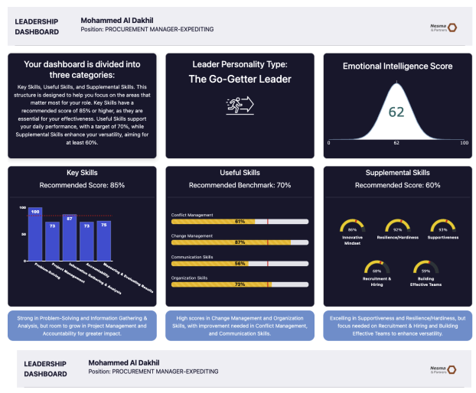

***Fig. 1.*** *illustrates the distribution of a leader’s scores across Key, Useful, and Supplemental soft skills, mapped to their assigned dashboard. Each bar represents a distinct competency, with score percentages reflecting performance relative to defined proficiency thresholds. This visualization allows both the leader and HR to immediately identify areas of strength, developmental gaps, and alignment with role expectations. See the full* [*Automated Dashboard Sample*](https://drive.google.com/file/d/1XcXZaYcgRXXITht8FEi1FgnxUTmdxgG-/view) *and in* *Appendix Figure A1**.*

This structure formed the basis for all subsequent discovery tool outputs and individualized development plans.

The final skill-tiered dashboards were compiled into the “[100 LDP Dashboard Categorization](https://drive.google.com/file/d/1ER8CUqob_sL5ObdDDW2rp7R4xwvKdrlb/view)” document and submitted to Nesma’s HR team for review. Their validation confirmed the alignment of the dashboards with organizational needs and functional expectations.

## 

## Phase 4: Stakeholder Feedback & Validation

The purpose of this phase was to validate the proposed structure, tone, and logic behind the Leadership Development Program (LDP) outputs. Feedback was collected from key stakeholders across Human Resources and Communications to ensure alignment before launching the Discovery-Tools.

### 4.1 Dashboard Content Review

After consolidating the proposed 13 dashboards types and associated skill tiering logic in the “100 LDP Dashboard Categorization” document, IVY & Company conducted review meetings with Nesma & Partners’ Human Resources and Communications teams. The document presented:

* A clustering of roles into 13 dashboard types
* Soft skill mapping across Key, Useful, and Supplemental skill pools
* Inclusion of Emotional Intelligence as a core behavioral pillar

Karim Jazzar (Director of Human Resources) and Salam Aljisihi (Head of Communications) both provided positive validation of the content and structure along with other members of the client team. No substantive changes were requested, confirming the internal coherence of the role grouping, skill logic, and behavioral framing. However, minor language adjustments were proposed to better align with internal communication standards.

### 4.2 Line Manager Report Feedback

A preliminary version of the [Line Manager Report](https://drive.google.com/file/d/11eXU-wDNxfWwWbxVmwcn_ihKsLRTpCTg/view?usp=sharing) was presented for internal validation. The document was designed to help Line Managers support their direct reports by interpreting dashboard data and guiding professional development. Feedback centered around tone clarity and role sensitivity, which were subsequently integrated. No content changes were requested.

### 4.3 HR Report Feedback

A sample [HR Report](https://drive.google.com/file/d/10EC6gdtzj4_4TdBDpbJxF0tkMBZz6nxi/view?usp=sharing) was also developed to demonstrate how group-level insights would be synthesized. The report highlighted key themes across leadership readiness, skill gaps, and proposed training needs. Nesma’s HR leadership validated the content and confirmed its utility as a strategic decision-making tool. Formatting updates were made to improve readability, and versioning was shifted from dashboard-style to a full report format based on internal preferences.

### 4.4 Terminology Standardization

To ensure consistency across all communications, reports, and dashboards, the following terminology was formally agreed upon and implemented across the program:

* **Leaders**, not managers
* **Key, Useful, Supplemental Skills**, as defined skill tiers
* **Discovery-Tools**, not assessments or self-discovery tools
* **Line Managers**, not senior managers or line leaders

These terms were adopted program-wide and consistently reflected across all tools, documentation, and stakeholder communication.

# 

# Part 2: Activation & Deployment

## 

## Phase 5: Communication Plan Kick-off

This phase marked the formal launch of the Leadership Development Program (LDP) to Nesma & Partners’ 100 participating Leaders. The communication rollout combined strategic messaging, asynchronous instruction, and participation tracking—all designed to maximize clarity, engagement, and compliance.

### 5.1 Email Sequence and Communication Strategy

To guide participants through the program and ensure alignment at every stage, a structured [email campaign](https://drive.google.com/file/d/1EVnzRagApSSviRbyHsNxAFkMsyled5nB/view?usp=sharing) was developed with a concise [FAQ](https://drive.google.com/file/d/1yR-j9u8EZ0iJBjvoXUyx1LNEI7Ho4RGA/view?usp=sharing) document to equip leaders with all the necessary information regarding the LDP program. Each message was tailored to a specific milestone in the LDP journey and reviewed by Nesma’s HR and Communications teams prior to distribution.

**Table 2: Emails and Communication Strategy**

| **Email** | **Date Sent (Placeholder)** | **Key Message Summary** |
| --- | --- | --- |
| **CEO Email** | January 6, 2025 | Official endorsement of the LDP by the CEO, positioning it as a strategic initiative aligned with Nesma & Partners' Vision 2030. Encouraged active participation and emphasized leadership growth. |
| **HR Email** | January 6, 2025 | Provided an overview of the LDP structure and upcoming steps. Introduced IVY & Company as the implementation partner and emphasized the importance of completing the Discovery-Tools. |
| **Ivy Email** | January 8, 2025 | Shared access to the pre-recorded LDP Workshop video. Informed Leaders that watching the full video and scanning the QR code at the end was a prerequisite to accessing the Discovery-Tools. |
| **Discovery-Tool Completion Confirmation Email** | Varies by date of step completion by leader | Confirmed receipt of completed Discovery-Tools and informed Leaders that their personalized dashboards were being developed. |
| **Dashboard Access Email** | Varies by date of step completion by leader | Delivered access to each Leader’s personalized dashboard, including their Leadership Index Score (LIS), emotional intelligence insights, and a tailored Personal Development Plan (PDP). |
| **Dashboard Clarification Support Email** | Varies by date of step completion by leader | Provided support to Leaders needing help interpreting their dashboards or using their development plans. |
| **Line Manager Report Email** | Pending to be sent with line Manager Report | Delivered dashboard summaries and PDPs for team members to Line Managers. Included guidance on how to support each Leader's development. |

### 5.2 The LDP Workshop Video & Verification

To deliver foundational concepts in an accessible format, a pre-recorded [LDP Workshop](https://www.canva.com/design/DAGZQ-CZMnI/3EShZasZJ20gjbwR-BrCfw/watch?utm_content=DAGZQ-CZMnI&utm_campaign=designshare&utm_medium=link2&utm_source=uniquelinks&utlId=h9f9e04e872) video was produced and finalized by early December 2024. This video was developed in response to Nesma’s request for a flexible alternative to a live session, ensuring all 100 Leaders could engage asynchronously.

**The video covered:**

* Overview of the Leadership Development Program
* Introduction to core topics: **Leadership Styles** and **Emotional Intelligence (EQ)**
* Key expectations and benefits of participation
* Emphasis on the confidential and developmental nature of the Discovery-Tools
* Introductions to the IVY team (Prof. Paris de L’Etraz, Prof. Gaelle Bou Abdo, Lola Tohme, Trinity Wildenstein)

To align with internal priorities, the video was iterated several times based on feedback from Nesma’s HR team, with special emphasis added on HR’s central role in the initiative.

### 5.3 QR Code Verification System

At the conclusion of the LDP Workshop video, participants were prompted to scan a unique QR code. This served as a verification step to confirm that Leaders had watched the full session before proceeding.

**QR scan logic:**

* Scanning the QR code registered the Leader in our system
* Only after scanning would the Leader receive access to the MANSSA and MEIQ Discovery-Tools
* This ensured all participants had the foundational understanding of the program's objectives before starting their Discovery-Tools

This step acted as a quality control filter to maintain comprehension and accountability prior to data collection. The QR-based tracking also allowed to monitor engagement in real time and tailor reminders based on actual participation.

## 

## Phase 6: Discovery-Tools Launch

The Discovery-Tools phase marked a critical diagnostic component of the Leadership Development Program (LDP), enabling data-driven insights into both leadership style and emotional intelligence across the participating cohort. Each leader had to complete two scientifically validated instruments—MANSSA and MEIQ—which collectively formed the analytical backbone for the dashboards and subsequent development plans. A total of 52 soft skills were assessed, with each leader evaluated on 15 prioritized skills grouped into three core categories. Emotional Intelligence (EQ) was treated as a distinct, high-priority domain given its critical importance across all leadership functions.

### 6.1 Participation Overview

Access to the tools was gated through the successful viewing of the LDP Workshop Video, confirmed via a unique QR code embedded at the end of the session. This ensured that all participants entered the diagnostic phase with the necessary foundational knowledge and context. Completion metrics were continuously monitored through timestamp logs and cross-referenced against video QR scans to maintain accuracy.

### 6.2 Technical Feasibility and User Experience

The tools were designed for high accessibility, offering full pause-and-resume functionality. This flexibility enabled leaders to complete their diagnostics in multiple sittings without data loss, minimizing disruption to daily work responsibilities. The average completion time was approximately 2 hours, 54 minutes for the MANSSA Discovery-Tool and 1 hour, 46 minutes for the MEIQ Discovery-Tool, reflecting a reasonable engagement threshold for executive-level participants. Credentials and access links were issued only after QR verification, reinforcing a sequential, structured participation flow.

### 6.3 Tool Design and Diagnostic Framework

The **MANSSA (Management Skills and Styles Assessment)** tool provided a structured leadership profile by identifying each leader’s dominant leadership style across a validated ten-typology model. These styles ranged from Mentoring and Visionary to Directive, Hands-Off, and Middle-of-the-Road, capturing both strategic orientation and interpersonal management tendencies. Each leader’s result reflected nuanced insights into how they communicate, delegate, influence, and adapt to organizational demands. These typologies formed the leadership architecture for understanding performance variability across clusters.

The **MEIQ (Mixed Emotional Intelligence Quotient)** complemented MANSSA by measuring emotional intelligence across four core domains: identification, facilitation, understanding, and regulation of emotions. The MEIQ’s mixed-methodology design—combining ability and self-perception inputs—yielded a well-rounded snapshot of each leader’s interpersonal maturity and adaptability. These scores directly fed into the calculation of the Leadership Index Score (LIS) and helped shape the EQ component of the LDNA framework.

### 6.4 Engagement Monitoring and Compliance Strategy

Engagement during this phase was systematically tracked using a centralized Excel tracker, which captured data on video viewing, discovery-tool access, and completion progress. In collaboration with Nesma’s HR team, IVY & Company coordinated a structured outreach and escalation plan to maintain momentum and accountability throughout the self-paced process.

While initial engagement varied due to workload and scheduling conflicts, the coordinated reminder strategy proved effective in driving completion. Communications were issued jointly by IVY and Nesma, with follow-ups extending to Vice Presidents where necessary. These reminders served both as progress nudges and formal deadlines, reinforcing the importance of timely participation.

**Table 3.4: Engagement Calculator & Weightings**

| **Component** | **Description** | **Max Points** | **Weight (%)** |
| --- | --- | --- | --- |
| QR Code Scanned | Whether the Leader scanned the code at the end of the workshop video | 25 | 25% |
| Discovery-Tools Completed | Completion of both MANSSA and MEIQ Discovery-Tools | 25 | 25% |
| Speed of Completion | Normalized by days taken from launch to completion | 20 | 20% |
| Proactive Communication | Leader-initiated emails (2 pts/email, max 10 pts) | 10 | 10% |
| Reminders Received | Deductions applied for each reminder sent (-1 point per reminder) | -10 | Up to -10% |
| Line Manager Escalation | Deduction if Line Manager escalation was needed due to inactivity | -5 | -5% |

The **total engagement score** ranked leaders from 0 to 100. This framework enabled real-time identification of low-engagement Leaders and allowed the team to adapt follow-up and escalation strategies accordingly. See [Appendix Table B3](?tab=t.yr2vvklec972#heading=h.af7etcm12ee6).

**Reminders for Watching the Leadership Workshop Video:**

* Jan 13: IVY – “Watch the Leadership Workshop Video (Due 2 PM Tuesday)”
* Jan 16: IVY – “Reminder: Mandatory Workshop Session”
* Jan 30: HR – “Reminder: Mandatory Workshop Session”
* Feb 4: HR – “Reminder: Mandatory Workshop Session”
* Feb 9: HR – “Reminder: Mandatory Workshop Session”
* Feb 12: HR – “Reminder: Mandatory Workshop Session” + QR Code Completion reminder
* Feb 16: HR – “Reminder: Mandatory Workshop Session” + QR Code completion reminder
* Feb 23: HR paused reminders; monitoring continued
* Mar 25: IVY – “Final Reminder – Complete Workshop & Discovery Tools by Mar 27, 3 PM KSA”
* Mar 27: IVY – Repeat of final reminder
* Mar 27: Mr. Houssam (Nesma) escalated to Vice Presidents urging full completion by Mar 31

**Reminders for Completing Discovery-Tools:**

* Jan 22: IVY – “Complete Your Discovery Modules”
* Jan 30: HR – “Complete Your Discovery Modules”
* Feb 4: HR – “Complete Your Discovery Modules”
* Feb 9: HR – “Complete Your Discovery Modules”
* Feb 12: HR – “Complete Your Discovery Modules”
* Feb 16: HR – “Complete Your Discovery Modules”
* Feb 23: HR paused reminders; monitoring continued
* Mar 14: IVY – “Urgent: ARCH Discovery Tools Completion Required Immediately” (Due Mar 18)
* Mar 16: IVY – “Final Reminder: Complete Discovery Tools by Mar 18, 3 PM KSA”
* Mar 25: IVY – “Final Reminder – Complete Discovery Tools by Mar 27, 3 PM KSA”
* Mar 27: IVY – Repeat of final reminder
* Mar 27: Mr. Houssam (Nesma) escalated to Vice Presidents urging full completion by Mar 31

This engagement strategy was highly effective in closing participation gaps and provided Nesma with a real-time behavior profile of the cohort. The Engagement Calculator became a predictive indicator used later in the program to recommend suitable leaders for mentorship participation and future training investments.

## Phase 7: Personal Development Plan Methodology

A cornerstone of the Leadership Development Program (LDP) was the creation of a dynamic Personal Development Planner (PDP) integrated into each leader’s dashboard. This component translated diagnostic outputs into actionable learning, enabling leaders to engage with relevant development material tailored to their individual performance profiles.

### 7.1 Overview of PDP Logic

The PDP was designed as a threshold-based recommendation engine. It used scores from each leader’s Discovery-Tools to identify development areas and assign tailored content for self-guided improvement. Development plans were structured to be modular, scalable, and personalized, ensuring high relevance across job clusters and leadership tiers.

### 7.2 Skill Threshold Framework

The foundation of the PDP engine was a structured threshold model aligned to the three skill pools used throughout the program:

* **Key Skills**: Threshold set at 85%
* **Useful Skills**: Threshold set at 70%
* **Supplemental Skills**: Threshold set at 60%

Each leader’s scores were benchmarked against these thresholds. Any skill falling below its pool-specific cut-off triggered a development recommendation. Additionally, if no score was below the threshold, the PDP automatically surfaced the five lowest-performing skills for ongoing improvement.

### 7.3 Customization Logic by Score Band

To ensure cognitive and developmental alignment, PDP recommendations were stratified by score band. Each skill below threshold triggered a content recommendation based on its performance level:

* **1–24**: Foundational resources (entry-level learning)
* **25–49**: Intermediate content (skill-building emphasis)
* **50–74**: Advanced resources (performance refinement)
* **75–100**: Expert insights (expansion and leadership excellence)

This allowed content relevance to scale with the leader’s proficiency, avoiding under- or over-challenging recommendations.

### 7.4 Content Architecture & PDP Development Methodology

Each leader’s Personal Development Plan (PDP) was built using a structured, multimodal content architecture that aligned to their individual performance profile. The PDP drew from a curated digital library of over 700 resources, including:

* **Books** – Industry-relevant titles for deeper behavioral insight (e.g., *Radical Candor*, *Leaders Eat Last*)
* **TED Talks** – High-impact videos for perspective shifts and practical inspiration (e.g., *The Power of Vulnerability*, *How Great Leaders Inspire Action*)
* **Online Courses** – Structured learning paths from Coursera, HarvardX, LinkedIn Learning, and others (e.g., *Leading People and Teams*, *Developing Emotional Intelligence*)
* **Influencers** – Key thought leaders to follow for continuous exposure (e.g., Simon Sinek, Brené Brown, Marshall Goldsmith)
* **Tactical Nudges** – Static text tips embedded into the dashboard to promote practical habit-building

The full PDP system was developed through a **hybrid process**:

* **Manual Design**: Subject matter experts and HR specialists at IVY & Company built a skill-by-skill resource map, aligned with behavioral competencies and stratified by performance tier. All materials were vetted for organizational and cultural relevance.
* **Automated Deployment**: A proprietary scoring engine powered by IVY & Company assigned content dynamically based on each leader’s normalized Discovery-Tool results. Recommendations were mapped to skill scores using the following tier logic:

| **Score Range** | **Development Level** |
| --- | --- |
| 0–24 | Foundational (Beginner) |
| 25-49 | Early Stage Development |
| 50–74 | Intermediate Improvement |
| 75–100 | High-Functioning (Stretch) |

Only skills that fell below performance thresholds (defined per dashboard tier logic—Key, Useful, Supplemental) triggered recommendations. For each flagged skill, 2–3 resources per category were assigned, resulting in a highly personalized PDP. A single PDP could contain up to 60+ unique content items, covering a full learning pathway across multiple formats.

While the system leveraged AI to support scalable content mapping, **all resources were hand-curated by IVY & Company’s learning specialists** to ensure quality, strategic alignment, and contextual relevance. This **human-AI hybrid approach** ensured both precision and personalization at scale—allowing each leader to receive development content that directly mapped to their specific needs and stage of growth.

PDPs were embedded directly into each leader’s dashboard in an **intuitive, visual format**, with content grouped by skill and categorized by type (books, courses, talks, influencers). To enhance adoption, **in-dashboard tutorials and pop-up guides** were added, helping leaders understand how to interpret and apply their development plans effectively.

This approach was grounded in **adult learning theory and multimodal learning science**, recognizing that leadership behaviors are best developed through diverse learning formats, repetition, and reflective practice. By combining reading, watching, doing, and reflecting, the PDP system promoted **sustained behavioral change** aligned with Nesma & Partners’ long-term leadership objectives.

### 7.5 Visual and Interactive Design

The PDP interface was visually structured for clarity and usability:

* Each skill pool was color-coded (Key, Useful, Supplemental)
* Skills under threshold were clearly flagged
* Resource links were embedded for direct access
* Each PDP began with a simple onboarding explanation, followed by modular content cards for each low-performing skill. Refer to *Figures 2.1 and 2.2* for an overview of the PDP interface.
* Leaders could explore their content independently and at their own pace

**Figure 2.1: PDP Interface - Onboarding Explanation**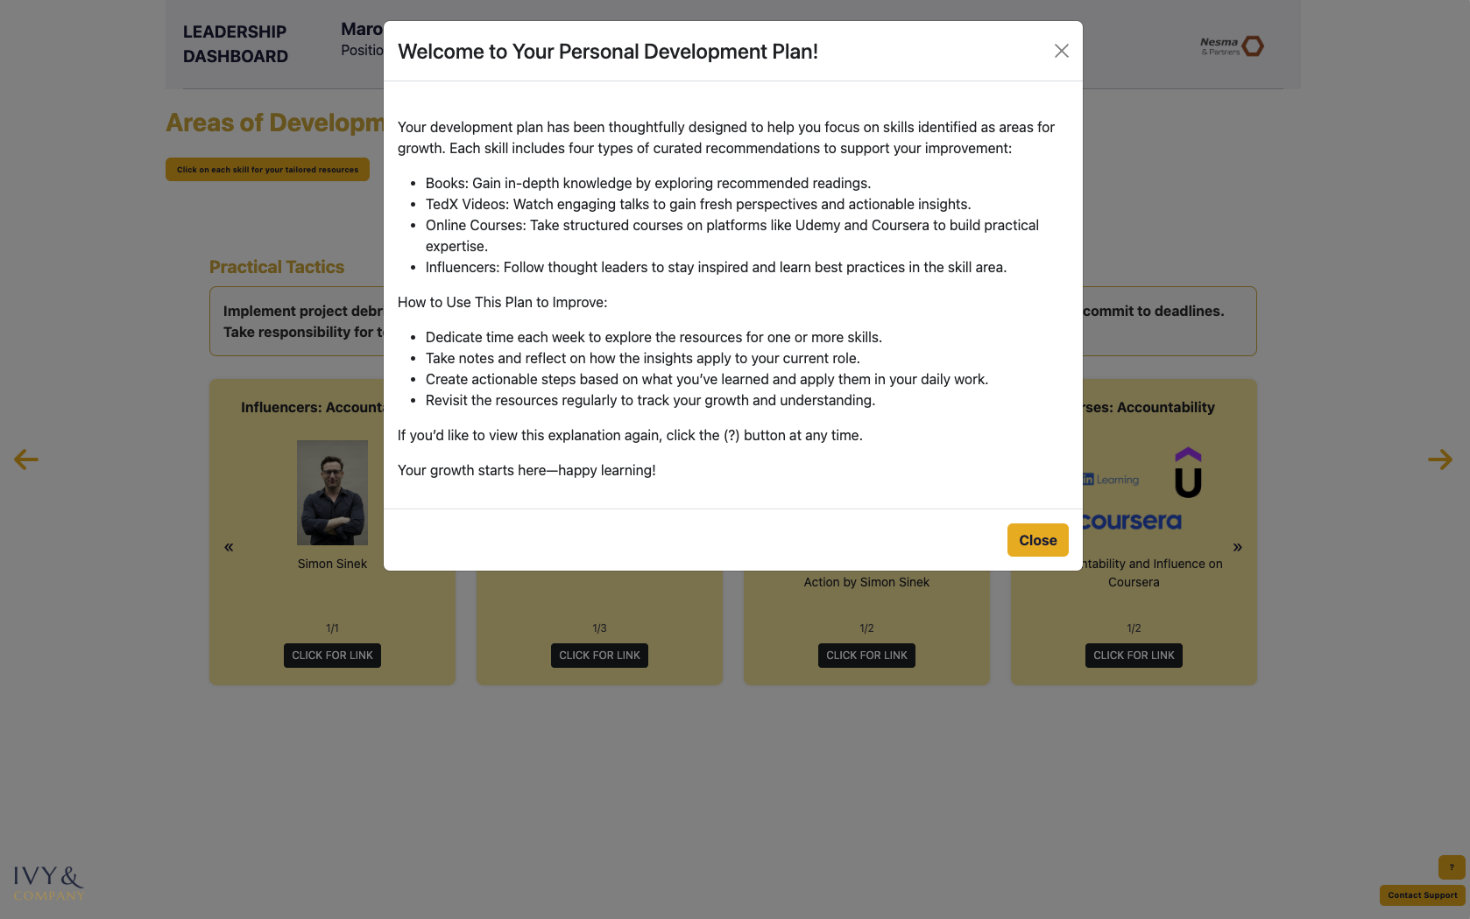

#### *Fig. 2.1. displays the leader’s personalized development plan (PDP) interface, which outlines curated learning resources tied to specific skills identified for growth. Each skill includes actionable content across four formats—books, TED-style videos, online courses, and thought leader recommendations. This structured view guides the leader in self-directed development, reinforcing both insight application and long-term behavioral change. See* *Figure A2 Appendix**.*

**Figure 2.2: PDP Interface - Areas of Development & Tools to Support** 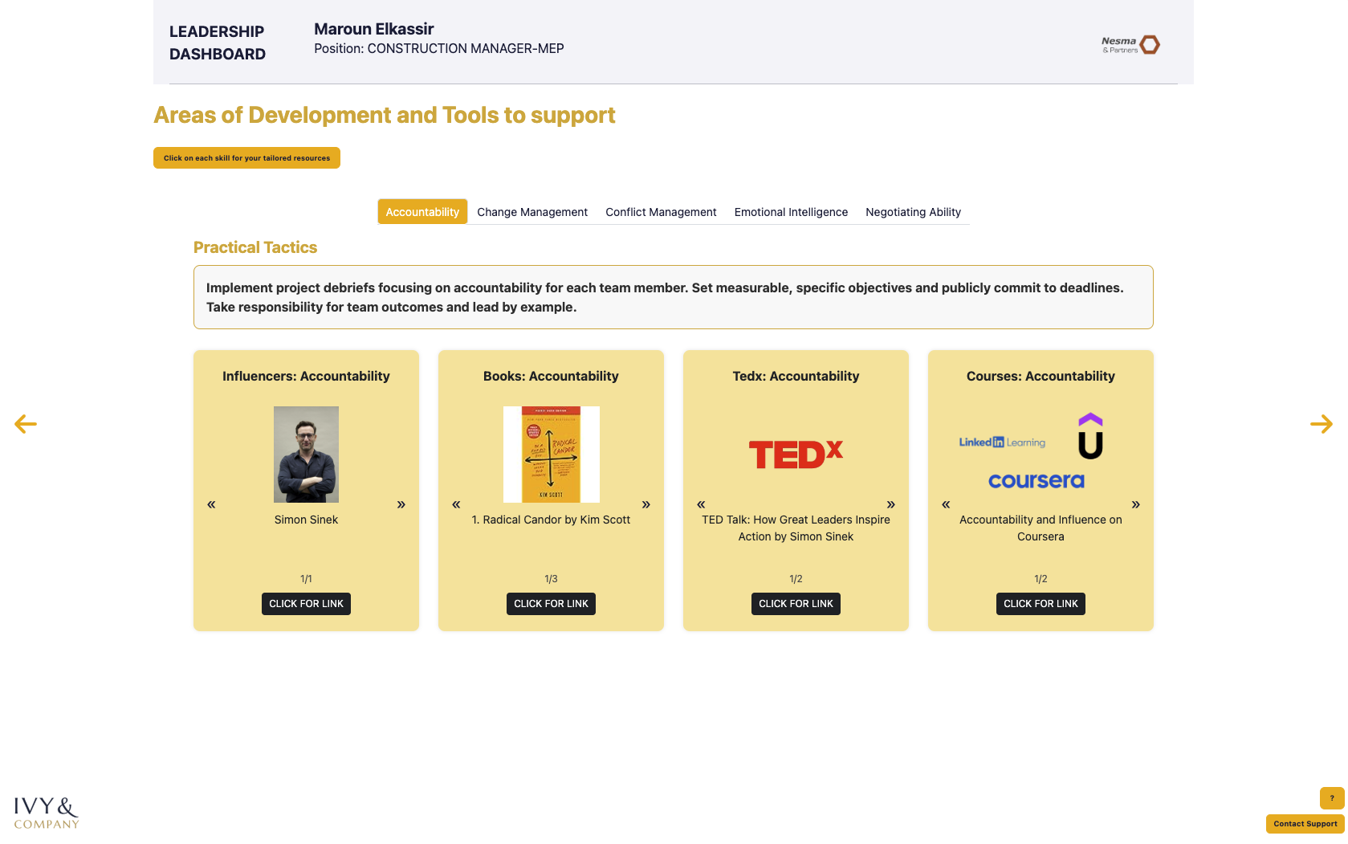

***Fig. 2.2.*** *showcases the curated development resources tied to a specific skill—in this case, accountability. Each resource is categorized by format: influencer content, recommended readings, TED-style talks, and structured online courses. The dashboard interface allows users to explore learning materials tailored to their development needs, supporting targeted, self-directed skill improvement. For the full PDP interface, please consult the Dash platform directly and see* *Figure A3 Appendix**.*

### 7.6 Supporting Consistency Across Dashboards

While each leader’s PDP was unique, the underlying architecture was standardized across the 13 types of dashboards. This allowed HR to monitor development at both the individual and cluster level, and maintain consistency in content quality and score-to-intervention mapping.

# Part 3: Findings & Forward Strategy

## Phase 8: Insights & Findings Analysis

### 8.1 Introducing Ivy's LDNA – A Leadership DNA Diagnostic Framework

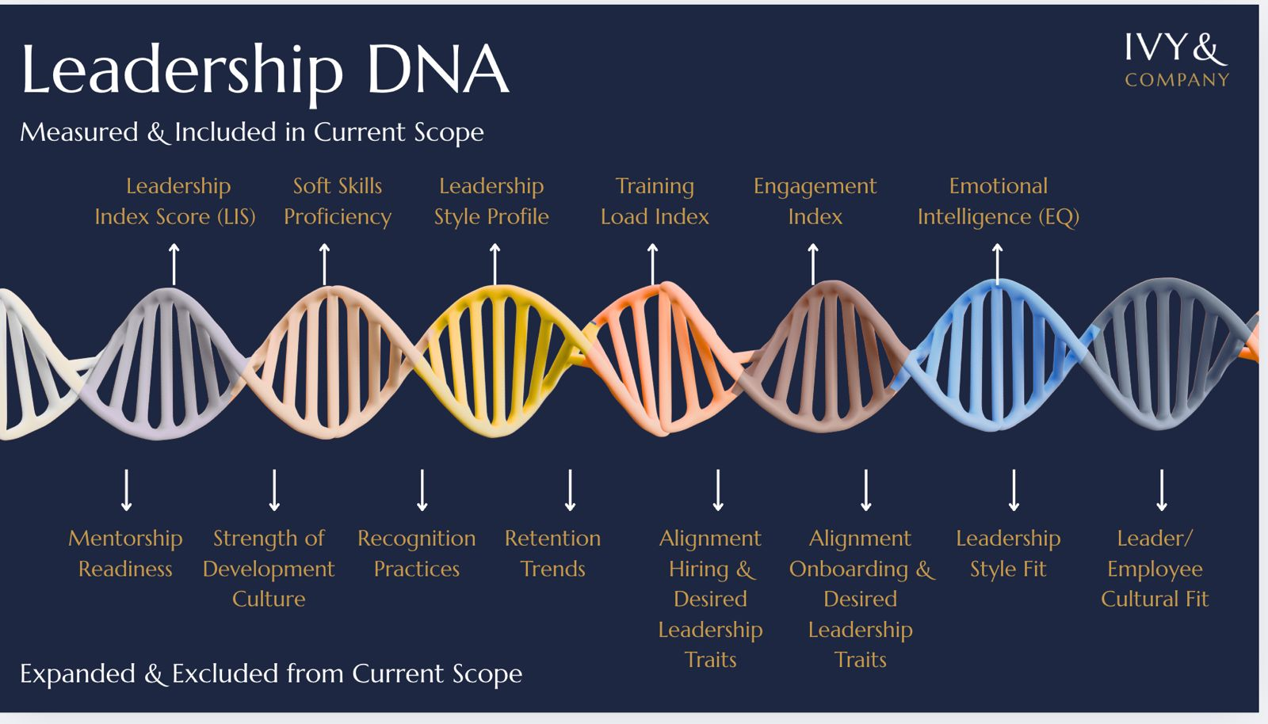

*Figure 3.1: LDNA Chromosome Structure — Placeholder for LDNA Visual Diagram*

#### 

#### **8.1.1 LDNA as a Strategic Lens**

The Leadership DNA (LDNA) is a proprietary diagnostic and technology-powered framework developed by IVY & Company. At its core is a live dashboard that links all components in the LDNA model, functioning as an intelligent **aggregator of leadership data to support real-time, evidence-based decision making.**

The LDNA maps leadership behavior at scale through this dynamic dashboard, offering an integrated behavioral genome that captures seven core dimensions of leadership performance. This results in a high-resolution portrait of individual and organizational leadership capability.

At its core, LDNA answers the strategic question:

**“Is our leadership—and the ecosystem around it—behaviorally, culturally, and structurally aligned with where the organization is headed?”**

Rather than relying on subjective perceptions of leadership effectiveness, the LDNA model uses validated evaluation tools, standardized measurement techniques, and cluster-level analysis to produce a representative "genetic" map of leadership at the organizational level.

The LDNA is modular by design, with its components and their potential weighting fully customizable based on an organization’s leadership priorities and desired future-state profile. While the current model is unweighted, the framework is intentionally designed to evolve as organizations refine their leadership benchmarks and strategy. This flexibility allows LDNA to remain aligned with shifting talent needs, cultural goals, and business contexts.

One of the most powerful future applications of LDNA lies in its ability to compare an individual leader’s Leadership DNA profile to the organization’s target LDNA model—enabling alignment analysis across multiple behavioral and strategic dimensions. This opens the door for precision planning around leadership fit, internal mobility, succession, and onboarding.

For organizations, LDNA provides scalable infrastructure to support:

1. **Talent calibration and role alignment:** Provides evidence-based leadership evaluation by comparing scores across roles and departments.
2. **Succession planning and promotion readiness:** Identifies high-potential leaders based on evidence, not just performance metrics.
3. **Targeted training strategy design:** Enables precise development interventions aligned to both individual performance and organizational needs.
4. **Cultural behavior mapping at the group or company level:** Reveals dominant leadership behaviors and potential culture drivers at the group or company level.
5. **Mentorship Pipeline:** Match-Making logic between mentors and mentees based on engagement, typology, and development needs.

This framework positions leadership development as a strategic capability, enabling behavioral capacity to evolve in parallel with business growth.

#### **8.1.2 LDNA Composition – Leadership Chromosomes**

The following represents the specific LDNA “chromosomes” measured in the current implementation for Nesma & Partners. Each component is scaled independently to a 100-point scale and reflects the behavioral dimensions included in this cohort’s Leadership DNA profile:

**Table 3.1: LDNA Composition Breakdown**

| **LDNA Component** | **Description** |
| --- | --- |
| **1- Leadership Index Score (LIS)** | Single metric (out of 100) that measures a leader’s fit for their role by combining job-relevant skills. >75 means role alignment. |
| **2- Emotional Intelligence (EQ)** | Standalone indicator of interpersonal adaptability and emotional regulation |
| **3- Soft Skill Depth** | Aggregated scores from Key, Useful, and Supplemental skill tiers |
| **4- Leadership Style** | Typology-based insight into natural behavioral patterns (e.g., Visionary, Mentoring) |
| **5- Engagement Behavior** | Participation metrics from program milestones and behavioral touchpoints |
| **6- Training Load** | Number and depth of flagged development needs |

Each domain is scaled on a 0–100 range to enable cross-comparison, and is visualized as a distinct “chromosome” in the organizational LDNA structure. See Table B1 in Appendix.

**Potential Expansion of LDNA: Toward a Full Leadership Culture Model**LDNA is IVY & Company’s proprietary leadership analytics framework—a dynamic, modular, and tech-enabled system that aggregates behavioral, performance, and strategic culture data into a unified decision-support dashboard. More than just a diagnostic model, LDNA acts as a behavioral operating system, allowing HR leaders to visualize talent readiness, cultural alignment, and capability gaps in real time.

While only a subset of LDNA’s full architecture was implemented in this pilot study with Nesma & Partners, the framework itself already exists as a fully developed enterprise tool. What was measured in this cohort represents only the first six of many possible “leadership chromosomes” available within the LDNA system. These were selected based on project scope, data availability, and current strategic priorities.

By design, LDNA can ingest and integrate a much broader range of organizational data. With access to additional internal sources—such as mentorship participation, recognition models, onboarding flows, and hiring practices—the LDNA dashboard could be expanded into a comprehensive leadership culture engine.

This full-scale deployment would allow Nesma & Partners to:

* Compare each leader’s behavioral profile against the organization’s desired leadership DNA
* Assess the alignment of talent pipelines with strategic values and cultural goals
* Build future-ready leadership architectures grounded in both skill and culture

**Table 3.2: Expanded LDNA**

| **LDNA Component (Included in Current Scope)** | **Expanded LDNA Framework Elements (Excluded from current scope)** |
| --- | --- |
| 1 - Leadership Index Score (LIS) | 7- Mentorship Readiness |
| 2 - Emotional Intelligence (EQ) | 8- Strength of the Development Culture |
| 3 - Average Soft Skill Score | 9- Recognition Practices |
| 4 - Leadership Typology(style) | 10 -Retention Trends |
| 5 - Engagement Behavior | 11 -Alignment of Hiring Practices with Desired Leadership Traits |
| 6 - Development Areas per Leader | 12 -Alignment of Onboarding Practices with Desired Leadership Traits |
|  | 13 -Leadership Style Fit |
|  | 14 - Leader/Employee Cultural Fit |

Appendix Table B11

This expanded LDNA model would empower Nesma & Partners to transition from behavioral diagnostics to full-spectrum leadership culture modeling—enabling smarter workforce decisions, deeper alignment across programs, and a long-term view of leadership transformation.

#### **8.1.3 Measurement Validity**

* **Skills and Leadership Styles** were assessed using the **MANSSA** **Discovery Tool**, and Emotional Intelligence (EQ) was measured through the **MEIQ Discovery Tool**—both white-labeled assessment solutions used under an exclusive agreement, selected and applied by IVY & Company for this program.
* **Normalization:** All component scores were normalized to a 100-point scale to support comparability across individuals and metrics.
* **Weighting Logic:** While LDNA itself is unweighted, individual components such as the LIS incorporate weighted contributions based on construct centrality. These weightings were tested and validated through internal modeling during the LDP pilot cohort.

#### **8.1.4 LDNA as a Diagnostic Tool**

The LDNA framework was developed to serve three core functions in organizational leadership analysis:

1. **Diagnostic:** To provide a high-resolution snapshot of current leadership strengths and deficiencies based on measurable traits and behaviors. It replaces anecdotal insight with quantifiable metrics, enabling accurate talent segmentation.
2. **Prescriptive:** To identify specific development interventions—training, mentorship, or reassignment—at the group and individual levels. LDNA helps match solutions to skill gaps rather than applying generic learning programs.
3. **Strategic:** To assess the degree of alignment between a company’s leadership composition and its long-term cultural and strategic priorities. LDNA serves as a planning layer for leadership pipeline design, succession management, and culture shaping.

Unlike traditional flat scoring systems, LDNA allows:

* Cross-sectional benchmarking (e.g., compare leadership health across D1–D13)
* Longitudinal tracking (e.g., how leadership readiness changes across cohorts or after interventions)
* Role-alignment evaluation (e.g., whether certain profiles support assigned responsibilities)

This makes LDNA not only a diagnostic model, but a decision-support system capable of powering forward-looking talent strategies.

**8.2 Nesma & Partners LDNA**

#### 8.2.1 Organizational - Level Leadership DNA (LDNA)

Nesma & Partners’ first cohort was analyzed using the LDNA framework to generate a high-resolution map of organizational leadership behavior. Drawing from 85 participating leaders, the company-wide LDNA was modeled across seven core dimensions: Leadership Index Score (LIS), Emotional Intelligence (EQ), Soft Skill Depth, Leadership Style, Engagement, Training Load, and Values Alignment Proxy. Each was normalized to a 100-point scale to allow consistent comparison.

The resulting profile reveals a strong leadership foundation with distinct developmental priorities in emotional regulation, communication, and executional consistencies.

**Table 3.3: Organizational LDNA Profile**

| **LDNA Domain** | **Organizational Mean** | **Interpretation** |
| --- | --- | --- |
| LIS | 77.87% | Cohort readiness above baseline of 70; majority are role-aligned |
| EQ | 71.4% | Developmental; 48 in intermediate tier (see below) |
| Skill Depth | 74.2% (avg. across all tiers) | Strong in Key Skills (e.g. Goal Setting); executional gaps (e.g., Communication, Accountability) persist |
| Leadership Style | 35.3% Mentoring | With ‘mentorship leadership style’ High people-centricity; strategic asset for mentorship and coaching culture |
| Engagement | 54.3% | Based on workshop completion, speed of completion of discovery-tools, reminders needed. |
| Training Load | Avg. 6.8 flagged skills | Majority fall in Intermediate tier (172), indicating refinement needs over remediation |

Appendix Table B2

#### **8.2.2 Engagement Monitoring Metrics**

Although the initial timeline targeted a one-week window for video completion and a second week for the Discovery-Tools, the flexible nature of the program resulted in extended participation timelines. A total of 85 out of 100 leaders ultimately completed both Discovery-Tools, resulting in a program-wide engagement score of **54.3%**.

To support this metric, IVY & Company tracked all participation behavior using a centralized engagement tracker. This included:

* Workshop video completion via QR scan
* Discovery-Tool submission status
* Time-to-complete metrics
* Reminder frequency and escalation activity

These inputs informed the **Engagement** component of the LDNA framework. A customized **Engagement Calculator** was developed to translate these behaviors into a standardized score, based on responsiveness, proactivity, and follow-through.

For a detailed breakdown of the calculator’s logic, scoring weights, and behavioral inputs, please refer to **Section 6.4: Engagement Monitoring and Compliance Strategy**.

#### **8.2.3 Developmental Distribution and Training Indicators**

A deeper analysis of training needs revealed both the **volume** and **nature** of developmental load across the cohort.

**EQ Tier Distribution:**

* **Beginner (0–59%)**: 4 leaders
* **Intermediate (60–74%)**: 48 leaders
* **Advanced (75–84%)**: 30 leaders

While few leaders scored below the 60% threshold, the large intermediate group signals a cohort that possesses baseline EQ capacity but requires stronger application in dynamic, high-stakes environments.

**Training Load by Skill (Top Domains):**

* **Emotional Intelligence**: 82 leaders flagged
* **Accountability**: 55 leaders flagged
* **Communication**: 39 leaders flagged
* **Change Management**: 28 leaders flagged

**Training Load by Tier:**

* **Beginner Tier (0–59%)**: 77 leaders
* **Intermediate Tier (60–74%)**: 172 leaders
* **Advanced Tier (75–84%)**: 109 leaders

These distributions confirm that most development needs lie in the intermediate range—leaders understand these skills but struggle to apply them consistently under complexity or pressure. The implication for training design is clear: emphasize **skill reinforcement**, **peer practice**, and **scenario-based application** over foundational instruction.

**8.2.4 EQ by Cluster: Behavioral Variability Across Functions**

**Figure 3.2: Box Plot of EQ by Dashboard**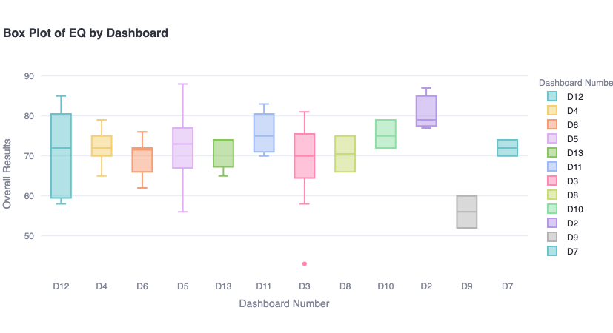

***Fig. 3.2.*** *The distribution of EQ across the 13 leadership clusters reveals wide variability. Clusters such as D2 (Executive Operations) and D11 (Strategy) exhibit relatively high median EQ scores, while D9 (Corporate Governance) and D13 (Support Services) show lower averages and greater score dispersion. These trends highlight where additional behavioral support—particularly in emotional awareness and interpersonal clarity—is most urgent. See Full Figure in* *Appendix Figure A4**.*

#### **8.2.5 LDNA by Dashboard Types (LDNA “Micro-Profiles”)**

Decomposing LDNA by leadership cluster (D1–D13) reveals role-sensitive skill differences. These "LDNA micro-profiles" reflect how leadership capability varies by function and hierarchy.

**Table 3.5: LDNA by Dashboard**

| **Dashboard Cluster** | **Key LDNA Insights** |
| --- | --- |
| **D1: Executive and Senior Leadership** | No leaders from this dashboard type were in the program. |
| **D2 – Executive Operations** | High EQ and LIS with strong resilience and strategic execution; minor gaps in collaboration, conflict resolution, and change agility may hinder cross-functional cohesion. |
| **D3 – Senior Management - Operations and Logistics** | Strong execution and project delivery; underperformance in resilience, coaching, and interpersonal domains; development needed in emotional regulation and mentoring for long-term leadership effectiveness. |
| **D4 – Logistics & Site Management** | Strong task execution and innovation; gaps in emotional regulation, supportiveness, and negotiation hinder cross-team alignment and adaptive leadership. |
| **D5 – Engineering** | Strong technical and Key Skills proficiency; however, gaps exist in team-building, interpersonal clarity, and communication. Beneficial leadership behaviors like Risk Management and Teamwork are underdeveloped. Needs support in people operations and resilience. |
| **D6 - Procurement & Supply Chain Management** | Strong execution in operational adaptability and data-driven thinking; gaps in communication, accountability, and cross-functional collaboration require attention to improve alignment and supplier engagement. |
| **D7 – Corporate Quality Assurance and Control** | Strong execution in quality control and problem-solving; gaps in emotional intelligence and conflict management may limit feedback flow and team openness |
| **D8 – Health, Safety, and Security** | Strength in structured communication and compliance; underperformance in conflict management, monitoring, and negotiation impacts ability to respond effectively to safety incidents and maintain team alignment under pressure. |
| **D9 – Corporate Governance** | Significant misalignment driven by low EQ and weak communication; critical gaps in emotional self-awareness and adaptability threaten governance consistency. Requires targeted support in interpersonal clarity and structured leadership routines. |
| **D10 – Financial and Risk Control** | Strong financial oversight and data interpretation capabilities; gaps in negotiation, conflict management, and risk adaptability may undermine strategic consensus and hinder collaborative financial leadership. |
| **D11 – Strategy & Business Development** | High LIS and strong strategic execution, but misalignment exists. Visionary leaders show gaps in innovation, emotional intelligence, and calculated risk-taking—traits essential for agile, forward-looking leadership in dynamic environments. |
| **D12 – Corporate Communications and Training** | Strong in team leadership and goal-setting; however, critical gaps in emotional self-awareness, communication clarity, and listening skills may hinder internal messaging and engagement effectiveness. |
| **D13 – Administrative and Support Services** | Strong delivery in problem-solving and team coordination; however, leadership effectiveness may be limited by gaps in conflict resolution, emotional intelligence, and performance monitoring. Development in interpersonal and evaluation skills is recommended to enhance administrative efficiency and collaboration. |

These micro-profiles enable HR to localize development interventions, identify talent risk areas, and deploy resources where alignment is weakest. See full table Appendix Table B4.

#### **8.2.6 Strategic Applications of Nesma’s LDNA**

The LDNA framework provides actionable insights that directly support Nesma & Partners in addressing the program’s three core strategic questions:

**Are Leaders in the Right Roles?**

* LDNA enables role-fit assessment using Leadership Index Scores (LIS), Emotional Intelligence (EQ), and Leadership Typology.
* Misalignment can be flagged early—for example, placing Visionary leaders in execution-heavy environments (e.g., D4, D6) may reduce effectiveness.

**What are the Skill Gaps?**

* Gaps are diagnosed through Soft Skill Depth and Training Load components.
* The most frequently flagged development areas across the cohort include Communication, EQ, and Accountability.

**What is the Roadmap to Close Those Gaps?**

* Training Load tiers (Beginner, Intermediate, Advanced) indicate development stage per skill.
* LDNA allows for precise targeting—e.g., designing intermediate-level training modules for large populations with mid-tier development needs.

Beyond diagnostics, LDNA serves as a strategic planning tool across five high-impact domains:

1. **Talent Calibration and Role Alignment:** LDNA allows for evidence-based evaluation of leadership fit by comparing LIS, EQ, and style distribution across roles and departments. Outliers can be flagged early for coaching or reassignment.
2. **Succession Planning and Promotion Readiness:** High-LIS, high-EQ leaders with balanced style profiles are strong candidates for advancement. LDNA enables promotion decisions to be grounded in evidence, not just performance metrics.
3. **Mentorship Pipeline Design:** Leaders with Mentoring typologies and strong readiness metrics are ideal mentors. LDNA supports match-making logic between mentors and mentees based on engagement, typology, and development needs.
4. **Training Prioritization and Leadership Archetyping:** Leaders can be clustered into leadership archetypes (e.g., “High EQ, Low Accountability”) to inform custom training cohorts. This increases training efficiency and outcome relevance.
5. **Culture Mapping and Transformation:** LDNA reveals dominant leadership behaviors, potential culture drivers, and areas of misalignment. These insights allow HR to manage leadership culture intentionally, shaping it in line with strategic objectives.

## Phase 9: Answering Our 3 Fundamental Questions

### 9.1 Are Leaders in the Right Roles?

To assess role alignment across Nesma’s leadership cohort, this section applies LDNA components to the first strategic question: Are leaders in the right roles? Using a mix of LIS, EQ, typology distribution, and skill performance, we offer a role-fit diagnostic at both cohort and dashboard levels.

#### **9.1.1 Overview: LIS an**d **LDNA Four Dimensions of Role Fit**

This role fit analysis is anchored in four core LDNA dimensions:

* **Skill Gap Patterns**: Execution, interpersonal, and adaptive capability
* **Emotional Intelligence (EQ)**: Interpersonal effectiveness and adaptability
* **Leadership Index Score (LIS)**: Composite readiness score (mean = 77.87)
* **Leadership Typology**: Behavioral style alignment to role demands

#### 9.1.2 Skill Bucket Performance

On average, leaders performed well across all three skill tiers:

* **Key Skills:** Leaders scored 84.3 on average indicating the highest performance area showing strong foundational leadership competencies.
* **Useful Skills:** Leaders scored 80.2 on average supporting competencies showing solid performance across leadership roles
* **Supplemental Skills:** Leaders 81.1 on average indicating contextual skills with unexpectedly strong performance indicators.

These averages suggest that while foundational understanding exists across most roles, skill depth varies by competency and pressure context—particularly in applied, interpersonal, and adaptive behaviors.

#### 9.1.3 EQ as a Role Enabler

Emotional intelligence, treated as a standalone domain, showed wide variability across the 13 leadership clusters.

Since EQ contributes heavily to interpersonal agility, stakeholder management, and conflict resolution, low scores may inhibit leadership effectiveness—particularly in high-collaboration or high-pressure environments.

* Executive and strategy roles (D2, D11) show the highest EQ performance, reinforcing their central role in driving people-centered decisions.
* Technical and project leaders (D5, D7) demonstrate strong EQ, highlighting the shift toward emotionally intelligent execution.
* Lowest EQ scores appear in governance, HR, and support (D9, D13, D12)—unexpected for people-focused functions, signaling a key development gap.

*Implication:* D9 leaders may be well-positioned in technical roles but need targeted development in emotional agility to succeed in broader leadership contexts.

**Figure 3.2: Median EQ Scores by Leadership Dashboard Cluster**

#### 

***Fig. 3.2***  *presents a bar graph of overall emotional intelligence (EQ) scores segmented by dashboard cluster. Each box represents the interquartile range, with whiskers indicating score variability and outliers denoted by individual points. This visualization highlights differences in EQ performance across functional groups, allowing for pattern recognition, targeted development planning, and role-specific behavioral insights. To access the full analysis, refer to the* *Streamlit in Appendix* *or see full figure in* *Appendix Figure A4**.*

#### **9.1.**4 **LIS as an Indicator of Role Fit**

The LIS represents a composite score that integrates leadership behavior, soft skill proficiency, and emotional intelligence.

**How Is the Leadership Index Score Calculated?**

Each component is first normalized to a 100-point scale. Final LIS is computed using the following weights:

| Component | Weight |
| --- | --- |
| Emotional Intelligence/Quotient (EQ) | 40% |
| Key Skills (KS) | 30% |
| Useful Skills (US) | 21% |
| Supplemental Skills (SS) | 9% |

A normal distribution was observed across the 85 assessed leaders, with a program-wide mean of 77.87%. To simplify role alignment benchmarking, we categorized leaders into three LIS brackets:

* **Between 0-60 (Below Threshold):** One leader completed a discovery tool in under 10 minutes, which raises concerns about the reliability of this data.

#### Between 60-70: Indicates a spectrum from development needs to possible misalignment, based on distance from the defined threshold

#### Between 70-84: Indicates a good role fit. Demonstrates strong alignment with role expectations; well-positioned for success with room for targeted growth

#### Between 85-100: Indicates a very strong role fit. Exhibits exceptional alignment with leadership expectations; highly suited for advanced responsibility, visibility, and succession planning

The following table indicates the Leadership Development Skills in the evaluated leaders:

#### Table 3.6: Percentage of Leaders per LIS Brackt

| **LIS** | **Percentage** | **Description** |
| --- | --- | --- |
| Between 60-70 | 14% | The 12 leaders scoring between 60 and 70 averaged only 3–5% below the threshold—indicating not a lack of role fit, but the need for closer review and potential targeted support. |
| Between 70-84 | 66% | As a first pilot, 60 leaders scoring between 70 and 84 demonstrate a strong organizational fit and a solid leadership baseline at scale. |
| Between 85-100 | 20% | Impressively, 12 out of 85 leaders—over 20%—scored above 85, showcasing an exceptional level of leadership alignment and signaling a strong bench of high-potential talent. |

This distribution shows that 86% of leaders are aligned or strongly aligned with their roles, validating the broader role allocation strategy. Leaders scoring under LIS 70 exhibited higher instances of red-zone skill scores (<70% in Key Skills), further reinforcing their need for support interventions.

#### **Figure 3.3: Leadership Index Score (LIS) Distribution**

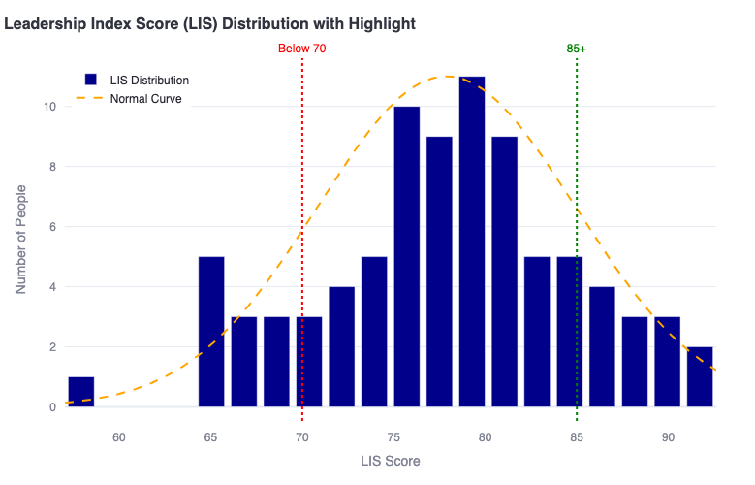

***Fig. 3.3.*** *displays the distribution of Leadership Index Scores across the assessed leadership cohort. The histogram is centered around a mean score of 77.87, with bracketed thresholds applied as follows: scores below 70 represent potential misalignment or development need; scores between 70 and 84 indicate strong alignment with role expectations and room for targeted growth; and scores of 85 or above reflect very strong role fit and readiness for advanced responsibility. This visualization enables clear identification of high- and low-performing leaders relative to the normalized benchmark, supporting cohort segmentation and strategic talent calibration. For the full LIS Distribution Histogram, see* *Appendix Figure A5**. Further, for the list of below-standard LIS leaders, see Full Table 3.5: Below Standard LIS Leaders in* *Appendix Table B5**.*

#### **Table 3.**7**:** Leaders Requiring Development Support

| **Name** | **Job Position** | **LIS** |
| --- | --- | --- |
| EL Chami Hassan | Security Manager | 65.2710 |
| Taha Anwar | Sr. Planning Manager | 68.553 |
| Alolaywi Mohammed | Training & Development Manager | 68.454 |
| Abu Ahmadeh Ali | Construction Manager-Mep | 64.3160 |
| Owida Mohamed | Commissioning Manager | 68.925 |
| Bshara Ayham | Construction Manager-Civil | 64.8815 |
| Alsultan Salsabeel | Communications Manager | 64.3030 |
| Mohammad Hallab | Site Manager - Civil | 67.2335 |
| Alamoais Shihab | Director - Internal Audit | 67.546 |
| Alabdullah Qassem | Government Relation Manager | 65.1750 |
| Alsamail Hassan | Security Manager | 66.9930 |
| Hefni Fathy Yosry | Project Manager-Civil | 57.0325 |

#### **9.1.**5 **Leadership Style and Role Fit**

Leadership typology was examined in tandem with LIS. “Mentoring Leaders” emerged as the highest-performing group, with the highest median LIS and lowest skill gap rates. This supports their suitability for people-focused roles or mentorship responsibilities. Conversely, “Hands-Off” and “Visionary” leaders showed wider LIS ranges and inconsistent skill scores, suggesting either a mismatch between style and responsibilities or unbalanced skill development.

*Implication:* While Visionary styles can excel in strategy roles (e.g., D11, D12), they may underperform in execution-heavy dashboards (e.g., D4, D6). Hands-Off leaders may benefit from stronger goal-setting, accountability, or team coaching.

**Typology Insights & Role Alignment**

Typology distributions reveal useful trends across dashboards, with mentoring leaders demonstrating superior competencies and role fit.

* **Mentoring Leaders** (n = 30): Consistently show high LIS and low skill gap rates—best suited for people-focused, strategic, or mentorship-heavy roles.
* **Go-Getters** (n = 23): Strong execution, but often flagged for delegation, regulation, and interpersonal friction.
* **Visionaries** (n = 12): Thrive in strategy clusters (e.g., D11), but may underperform in execution-heavy environments (e.g., D4, D5).
* **Hands-Off & Permissive**: Small sample size but show widest LIS variability and weak accountability—high coaching need.

This insight reinforces the strategic value of mentorship as a development lever, providing a strong rationale for expanded investment in mentorship programs across the organization.

#### **Figure 3.4: LIS Distribution Across Leadership Typologies**

***Fig. 3.4.*** *shows the variation in Leadership Index Scores (LIS) across different leadership style typologies. The box plots reveal how average LIS performance differs between leader types—such as Mentoring, Visionary, or Hands-Off—offering insight into which styles are most strongly associated with readiness and behavioral alignment. To see LIS by Typology, refer to* *Appendix Figure A6**.*

#### **Figure 3.5: Average Soft Skill Scored by Leadership Typologies**

***Fig. 3.5.*** *presents a heatmap of average soft skill scores across leadership typologies. Darker shades indicate higher proficiency levels across a spectrum of competencies. This visualization allows for comparative analysis of leadership behavior patterns, highlighting which styles demonstrate particular strengths or developmental gaps. For Average Skill Scores by Typology, refer to* *Appendix Figure A7**.*

#### **9.1.**6 **Skill Patterns, Mentorship Potential, and Hotspots**

To deepen the role-fit analysis, we examine leadership behavior through skill strength, development gaps, typology alignment, and engagement indicators. These patterns offer a more nuanced understanding of where leaders excel, where they struggle, and how the organization can better leverage mentorship potential and strategic upskilling.

**Skills Where N&P Excels the Most**

N&P demonstrates exceptional competency in three critical leadership areas, with minimal training needs across the cohort:

* **Goal Setting**: Exceptional competency with only 1 person requiring additional training
* **Calculated Risk Raking**: Strong strategic decision-making with only 1 person requiring additional training
* **Supportiveness:** Excellence in team support and collaboration with just 1 person recommended for development

The table below highlights the top 10 skills with the fewest recommendations—indicating these are strengths or not current gaps within the cohort.

#### Figure A15: Training Buckets per Skill and Proficiency Level

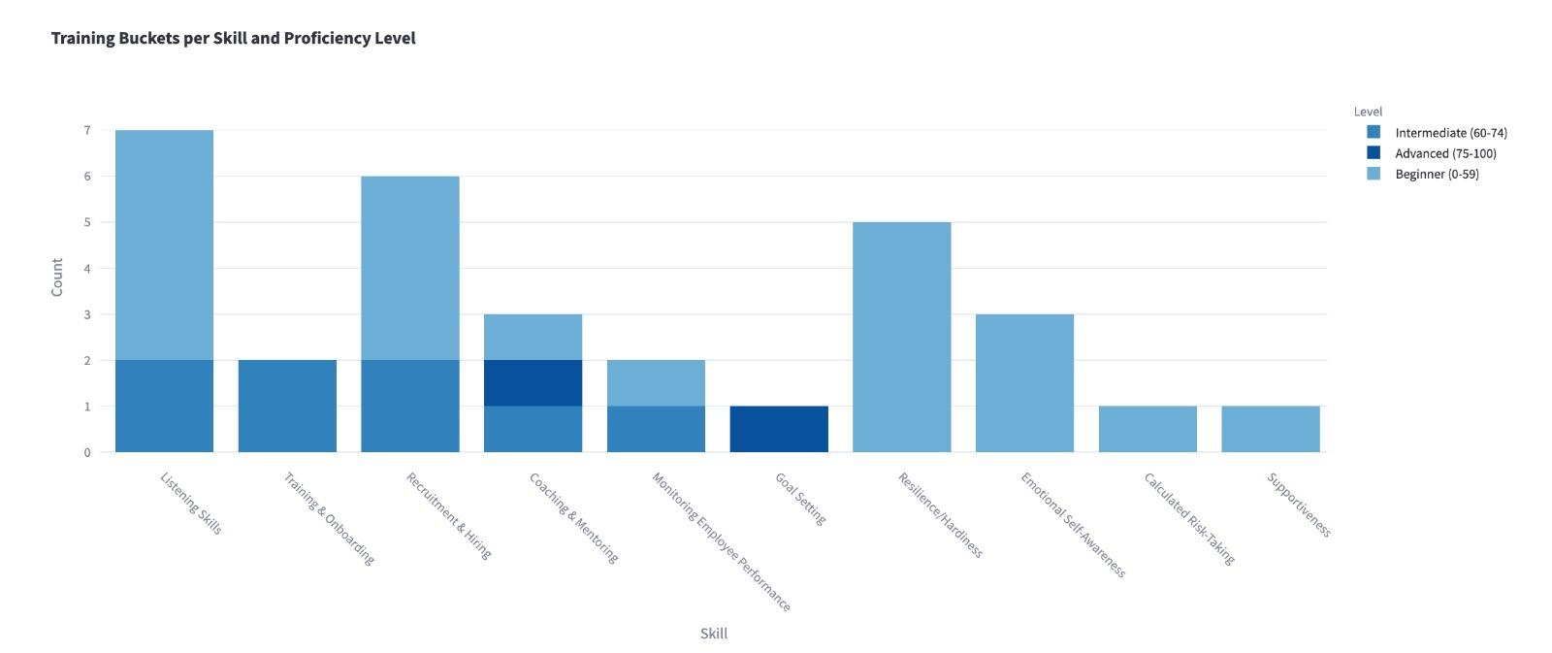

***Fig. A15.*** *illustrates the distribution of leaders across training buckets by skill and proficiency tier (Beginner, Intermediate, Advanced). The most frequently flagged development areas include Listening Skills, Resilience/Hardiness, and Recruitment & Hiring—predominantly at the Beginner level. This visualization reinforces the behavioral focus areas identified for Wave 1 of the training rollout and supports the need for foundational upskilling across people-centered capabilities. For full cluster-to-skill mapping and tier assignment, see Appendix Report D3.*

Additionally, Figure 3.6 showcases the top 10 strongest skills by average score not based on minimal training required across the cohort. The highest-performing areas reflect goal alignment, initiative, and structured execution:

* **Goal Setting** (86)
* **Social Insight** (84)
* **Drive** (83)
* **Customer Orientation** (81)
* **Project Management** (79.9)

These competencies confirm Nesma’s strength in operational leadership and strategic planning— especially within high-LIS clusters like D2 and D11.

#### **Figure 3.6: Top 10 Strongest Skills by Average Score**

**Fig. 3.6.** highlights the ten highest-performing behavioral skills across the assessed leadership cohort. Scores are based on normalized averages from all dashboards, with top skills including goal setting, social insight, drive, and customer orientation. This visualization reflects areas of collective strength and provides a foundation for peer learning, mentorship selection, and reinforcement in performance management systems. For a full view, see Appendix Figure A8.

**Mentorship Readiness vs. Development Needs**

Over **35% of the cohort were classified as Mentoring Leaders**, with high LIS and low skill gap rates—indicating strong suitability for peer development roles. However, **Coaching & Mentoring** itself appears in the weakest 10 skills (avg. score = 68), revealing a gap between potential and practice. These leaders may understand the value of mentorship but require structured support to deliver it effectively.

**Behavioral Hotspots: Low-Performers & Engagement Risks**

* **8 leaders (9.4%) scored below the LIS readiness threshold** (LIS < 67.33), with clustered representation in D3, D4, D5, D8, D9, and D12.
* These same dashboards often scored low in EQ (e.g., D9 average EQ = 56) and soft skills like **Conflict Management** and **Monitoring Performance**.
* Additionally, **50% of leaders had Engagement Scores under 60**, suggesting a risk of disengagement that may impact role alignment and development follow-through.

**9.1.7 Answering the question: Are Leaders in the Right Roles?**The data strongly supports the following conclusions:

* **Strong Role Fit Across the Organization:** 85/100 of participating leaders scored above the LIS readiness threshold (70+), with skill profiles that closely aligned to their job demands. This indicates a high rate of accurate placement and strong talent decisions made by Nesma’s leadership team.
* **Validation of Organizational Insight:** High-scoring leaders demonstrate that existing role assignments are behaviorally sound—reinforcing the effectiveness of internal promotions, role design, and succession practices.
* **Development is Ongoing—even for Top Performers:** While well-placed, even high-performing leaders show room for growth in areas such as cross-functional influence, strategic delegation, or resilience—areas that distinguish technical competence from long-term leadership strength.
* **Targeted Support for a Small At-Risk Segment:** Approximately 8% of leaders scored below LIS thresholds and showed consistently low EQ or soft skill performance. These individuals should receive tailored coaching and PDP refinement to support alignment and growth in their current roles.
* **Leadership style should be factored into future talent deployment -** especially when mapping Go-Getters to operations (e.g., D4/D5) and Mentoring leaders to strategic or developmental roles (e.g., D2/D11).
* **Mentoring readiness is a strength.** Over 35% of leaders exhibit Mentoring traits and above-average LIS, reinforcing the case for formal mentorship programs as a development tool.
* Low-performing outliers, especially those with compounded low LIS, EQ, and engagement scores, represent high-priority targets for review and targeted intervention.

While the majority of leaders demonstrate strong alignment to their current roles, this alignment does not imply complete readiness. Leadership effectiveness is not static—it depends on the continuous refinement of behavioral, emotional, and executional competencies. To sustain and elevate performance, it is essential to identify which specific skills require further development.

This brings us to the second strategic question guiding this analysis:

### 9.2 What are the Skill Gaps?

With the confirmation that most leaders are behaviorally aligned to their current roles (see 8A), the next question becomes: *how can their effectiveness be enhanced?* This section investigates leadership development opportunities through the lens of observed skill gaps. The analysis draws on leader-level diagnostic results, training tier assignments, and leadership typologies to uncover performance blind spots, identify common challenges, and provide a foundation for the strategic training roadmap.

#### **9.2.1 Skill Gaps Framework Explained**

Skill gaps were identified using score thresholds defined for each leader’s dashboard type:

**Table 3.8: Skill Gap Threshold**

| **Skill Tier** | **Score Threshold** | **Definition** |
| --- | --- | --- |
| Key Skills | ≥ 85% | Mission-critical skills required for role success |
| Useful Skills | ≥ 70% | Enable day-to-day team performance and productivity |
| Supplemental Skills | ≥ 60% | Broaden leadership effectiveness, not essential to role |
| Emotional Intelligence (EQ) | n/a | Modeled as a standalone domain |

Appendix Table B6.

Any skill falling below the threshold was flagged and classified into one of three development tiers based on severity:

**Table 3.9and : Skill Development Tier**

| **Development Tier** | **Score Range** |
| --- | --- |
| Beginner (fundamental skill development required) | 0–59 |
| Intermediate (refinement and practice needed) | 60–74 |
| Advanced (targeted improvement opportunities) | 75–84 |

Each flagged skill was assigned tailored development content in the leader’s PDP. These classifications also informed training cluster design and HR development planning. See Appendix Table B6.

#### **9.2.2 Skill Gap Prevalence and Distribution Across the Cohort**

Out of the 85/100 participating leaders, **100% of the leaders were identified with at least one flagged skill gap**, confirming that upskilling is relevant to the full cohort. On average, each leader had **6–8 targeted development areas**, with the majority found in the **Key** and **Useful** skill categories.

#### **Table 3.**10**: Most Common Skill Gaps (By # of Leaders Needing Training)**

| **Skill** | **Total # of Leaders Needing Training** | **Beginner**  **(0–59)** | **Intermediate**  **(60–74)** | **Advanced**  **(75–84)** |
| --- | --- | --- | --- | --- |
| Emotional Intelligence (EQ) | 82 | 4 | 48 | 30 |
| Accountability | 55 | 4 | 30 | 21 |
| Communication | 39 | 4 | 19 | 16 |
| Change Management | 28 | 6 | 16 | 6 |

These results underscore the need for broad-based upskilling in interpersonal effectiveness and emotional self-management. Even high-scoring leaders had development areas, particularly in EQ and execution-aligned skills such as **Accountability** and **Follow-through**. See Appendix Table B8.

#### **9.2.3 Training Tier Distribution Across the Cohort**

* **Beginner-level training (0–59):** 77 leaders
* **Intermediate-level training (60–74):** 172 leaders
* **Advanced-level training (75–84):** 109 leaders

This breakdown confirms that while some skills need foundational reinforcement (Beginner), the majority of the training needs lies in the Intermediate range—suggesting leaders generally understand the skill but lack consistent application under pressure or complexity.

#### **9.2.4 Skill Gap Analysis by Dashboard Type**

To contextualize development needs by functional cluster, we analyzed training needs across the 13 dashboard types (see Appendix Figure A7: Skill Score Heatmap by Dashboard). The analysis focused on identifying skills that scored below 70%, categorized as “development priorities.” Confirmed and expanded insights include:

* **D1- Executive and Senior Leadership** has no data available as no leaders from this dashboard group participated in the pilot program.
* **D2 – Executive Operations** scored consistently high on overall LIS and EQ averages, but presented selective gaps in *Rumination*, *Recognition of Others’ Emotions*, and *Comfort with Emotions*. These skills are crucial for navigating the strategic demands and relational dynamics at the executive level.
* **D3 – Senior Management - Operations and Logistics** scored high in execution and project delivery, but had an underperformance in resilience, coaching, and interpersonal domains; development needed in emotional regulation and mentoring for long-term leadership effectiveness.
* **D4 – Logistics & Site Management** showed Intermediate-level gaps in key execution-based and emotional competencies, particularly in *Listening Skills*, *Emotional Self-Awareness*, and *Comfort with Emotions*. These suggest a need for strengthening interpersonal clarity and emotional regulation under operational pressure.
* **D5 – Engineering & Technical Management** similarly displayed gaps in *Negotiation Ability*, *Emotional Integration*, and *Recognition of Others’ Emotions*. These point to challenges in both technical collaboration and leadership empathy.
* **D6 - Procurement & Supply Chain Management** scored high in operational adaptability and data-driven thinking with gaps in communication, accountability, and cross-functional collaboration that require attention to improve alignment and supplier engagement.
* **D7 – Corporate Quality Assurance and Control** have strong execution in quality control and problem-solving with gaps in emotional intelligence and conflict management may limit feedback flow and team openness.
* **D8 – Health, Safety, and Security** have strengths in structured communication and compliance and an underperformance in conflict management, monitoring, and negotiation impacts ability to respond effectively to safety incidents and maintain team alignment under pressure
* **D9 – Corporate Governance & Compliance** emerged as a critical development priority. It had the highest number of low-scoring skills, including *Change Management*, *Influence*, *Communication*, *Resilience*, and multiple core emotional intelligence domains. This wide gap spectrum indicates both interpersonal and strategic capacity building needs.
* **D10 – Financial and Risk Control** have strong financial oversight and data interpretation capabilities with gaps in negotiation, conflict management, and risk adaptability which can undermine strategic consensus and hinder collaborative financial leadership.
* **D11 – Strategy & Business Development** have very high LIS and strong strategic execution although misalignment exists. Visionary leaders show gaps in innovation, emotional intelligence, and calculated risk-taking—traits essential for agile, forward-looking leadership in dynamic environments
* **D12 – Corporate Communications and Training** demonstrated high EQ variance, with low scores in *Conflict Management*-related areas such as *Self-Control*, *Listening*, and *Emotional Reflection*. These suggest the need for tailored emotional intelligence upskilling, despite the department’s communication focus.
* **D13 – Administrative and Support Services** have strong delivery in problem-solving and team coordination but, leadership effectiveness may be limited by gaps in conflict resolution, emotional intelligence, and performance monitoring. Development in interpersonal and evaluation skills is recommended to enhance administrative efficiency and collaboration

These insights reinforce that while each dashboard type has a distinct functional emphasis, **emotional regulation**, **interpersonal clarity**, and **execution discipline** remain universal development areas across the organization.

This suggests that while each dashboard type has a different functional emphasis, execution, emotional regulation, and interpersonal clarity remain universal development areas.

#### **9.2.5 Skill Gaps by Leadership Typology**

Each leader was also assigned one of seven leadership typologies from the MANSSA Discovery-Tool. Overlaying skill gaps onto these typologies reveals powerful trends:

#### 

#### **Table 3.1**1**: Typology Breakdown (Cohort Distribution)**

| **Typology** | **% of Leaders** |
| --- | --- |
| The Mentoring Leader | 35.3% |
| The Go-Getter Leader | 27.1% |
| The Visionary Leader | 14.1% |
| The Middle-of-the-Road | 10.6% |
| The Hands-Off Leader | 5.88% |
| The Parental Leader | 5.88% |
| The Permissive Leader | 1.18% |

Appendix Table B9

#### **9.2.6 Typology-Specific Development Patterns**

* **The Go-Getter Leader** (Execution-oriented): Consistent skill gaps were observed in Delegation proxies such as *Negotiating Ability* and *Listening Skills*, as well as in Emotional Regulation domains like *Rumination* and *Emotional Reflection*. These suggest high drive but limited trust or flexibility under pressure.
* **The Visionary Leader** (Strategic-focused): Frequent gaps included *Accountability*, *Time Management*-adjacent skills (*Self-Motivation*, *Emotional Facilitation*, *Planning*), and interpersonal dynamics (*Empathy*, *Listening*). These patterns indicate challenges in translating big-picture thinking into sustained execution.
* **The Mentoring Leader** (People-centric): Scored well on overall EQ and LIS but had recurring gaps in *Conflict Management*, *Constructive Feedback*, and *Rumination*, suggesting discomfort with difficult conversations or emotional overprocessing.
* **The Middle-of-the-Road:** Displayed the highest number of low scores across both execution and interpersonal domains, including *Accountability*, *Conflict Management*, *Change Management*, and *Self-Motivation*.
* **Hands-Off Leaders**: Identified issues were primarily in *Listening*, *Managerial* *Courage*, and *Emotional Regulation*, reflecting a lack of assertive engagement or responsiveness in leadership settings.
* **The Parental Leader**: Gaps focused on *Listening*, *Negotiation*, and *Managerial Courage*, indicating potential overprotection or difficulty delegating under stress.
* **The Permissive Leader**: Though a small cohort, they showed deficits across nearly all skill domains—highlighting major upskilling needs, especially in *Accountability*, *Change Management*, *Emotional Integration*, and *Conflict Resolution*.

These insights support the idea that different leadership styles come with distinct development blind spots. Customizing training based on typology (as well as score level) can dramatically increase developmental efficiency and learner engagement.

**Conclusion:**

These findings confirm that leadership styles come with specific skill blind spots. Typology-specific development planning can significantly improve the precision and effectiveness of training interventions. This insight supports the customization of learning journeys by both typology and score level to enhance engagement and impact.

By identifying patterns through expanded data collection, we can proactively anticipate future training needs—and more strategically define the types of talent we aim to hire, retain, and promote.

#### 

#### 

#### **9.2.7 EQ Development Tier Distribution**

**Table 3.12: EQ Development Distribution**

| **Development Tier** | **# of Leaders** | **Interpretation** |
| --- | --- | --- |
| Beginner (0–59%) | 4 | Very limited emotional self-regulation or awareness; foundational development needed |
| Intermediate (60–74%) | 48 | Functional EQ skills present, but require further refinement under pressure or ambiguity |
| Advanced (75–84%) | 30 | Solid EQ capabilities, with room for optimization in complex or high-stakes environments |

Appendix Table B10

The fact that nearly half the cohort (48 leaders) were placed in the **Intermediate EQ development tier** is a positive indicator: it suggests that the majority of leaders already possess a reasonable level of emotional intelligence. However, it also highlights that emotional mastery—particularly in moments of stress, conflict, or ambiguity—is still an area for collective growth.

This insight has implications for the future training roadmap. Rather than foundational emotional literacy, the focus should be on **application-oriented EQ**: navigating high-pressure environments, leading through change, resolving interpersonal tensions, and cultivating inclusive leadership behaviors.

This trend also reinforces the potential of mentorship programs. Given that Mentoring Leaders typically exhibit strong EQ traits, they may be best positioned to guide others in developing interpersonal and intrapersonal awareness through structured mentoring initiatives.

#### **9.2.8 EQ Development as a Cross-Cutting Priority**

Emotional Intelligence (EQ) was modeled as a standalone domain within the LDP and treated as a non-negotiable development pillar. 100% of leaders were assigned EQ-related development content in their Personal Development Plans, regardless of whether they fell below the 70% performance threshold.

This decision was made based on the central role EQ plays in effective leadership—particularly in stakeholder-facing, cross-functional, and people-management roles. While not all leaders scored below threshold, the inclusion of EQ in the analysis was a strategic measure to promote emotional self-awareness, interpersonal empathy, and leadership adaptability across all leadership tiers.

**Figure A16: Top 7 Weakest Skills by Average Score**

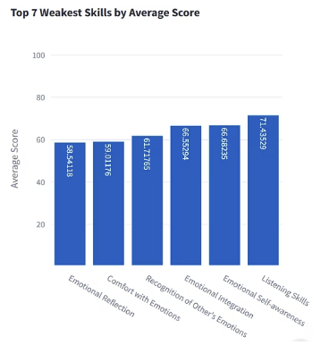

***Fig. A16.*** *highlights the seven lowest-scoring skills across the leadership cohort, based on average assessment scores. Emotional Reflection, Comfort with Emotions, and Recognition of Others’ Emotions represent the most pronounced development gaps, with average scores below 62%. These findings emphasize the critical need for emotional intelligence–focused training interventions. Listening Skills and Emotional Self-Awareness, although comparatively higher, still fall within the weak performance band and further validate their prioritization in Wave 1 of the HR-Led Training Strategy. See Appendix Report D3 for individual and cluster-level breakdowns.*

The cohort’s seven weakest skills correspond to EQ components within the Discovery tools, confirming emotional intelligence as the most prominent development gap. EQ has a direct correlation with the Leadership Index Score (LIS) playing a 40% weight in the equation.

These areas of development fall under the below framework:

* **Emotional Self-Awareness:** Developing leaders' capacity to recognize and understand their own emotions and their impact on others.
* **Interpersonal Empathy:** Enhancing the ability to understand and respond to the needs and perspectives of team members.
* **Leadership Adaptability:** Building flexibility in leadership approach based on situational needs and stakeholder requirements.

These qualities are essential across all leadership tiers and functional domains, making EQ a non- negotiable development pillar throughout the organization.

#### **9.2.9 Skill Gap Patterns & Performance Zones**

Analyzing the link between LIS and skill bucket performance (Figure A5) revealed:

* All leaders scoring above LIS 80 had Key Skill performance over 80 (green zone)
* In contrast, ~50% of leaders under LIS 70 fell into “red” skill zones (<70% on Key Skills)

Skill gap patterns further reinforce LIS accuracy in indicating leadership readiness. Notably, the weakest average skill across the cohort was *Emotional Self-Awareness* (52.8), which undermines role fit by limiting adaptability, coaching potential, and relational feedback cycles.

*Implication:* Skill readiness strongly correlates with LIS, and leaders under LIS 70 face both knowledge and behavior-based challenges.

**Figure 3.7: Leaders by LIS Band and Key Skill Performance**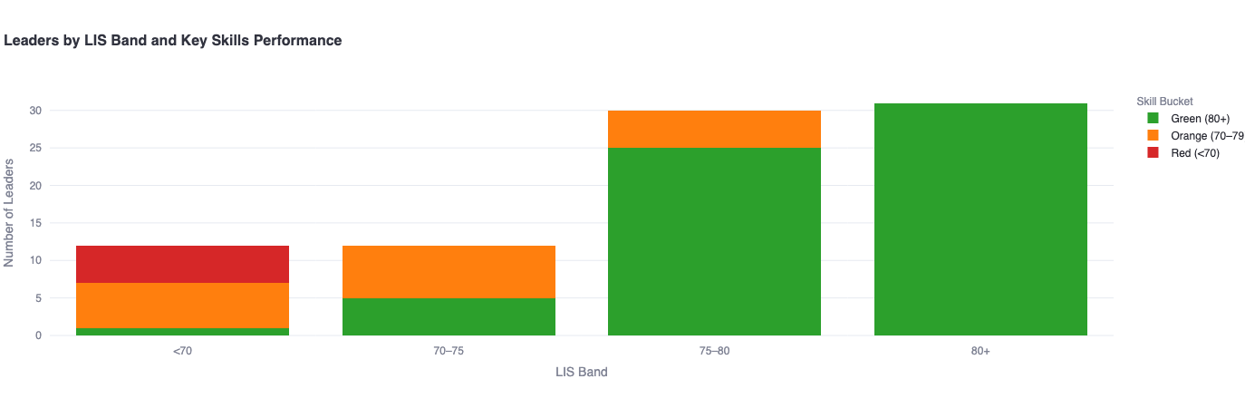

***Fig. 3.7.*** *illustrates the distribution of leaders across LIS bands, segmented by Key Skill performance tiers. The color-coded bands (green, orange, red) represent the proportion of leaders meeting, approaching, or falling below threshold performance for critical competencies. This view supports targeted intervention planning based on both overall readiness and role-critical skill gaps. For Leaders by LIS Band and Key Skill Performance, refer to* *Appendix Figure A9**.*

**9.2.10 Mentoring Drives Role Fit, Yet Delivery Skills Remain Underdeveloped**

One of the most compelling insights from this phase of analysis is the paradox between mentoring potential and mentoring readiness. Over 35% of the leadership cohort were classified under the Mentoring typology—demonstrating high LIS scores, low skill gap rates, and consistent alignment with people-centric leadership. This group exhibits strong potential for peer development and organizational knowledge transfer.

However, while the cohort displays natural mentoring tendencies, the Coaching & Mentoring skill itself emerged as one of the weakest competencies across all dashboards, with an average score of 68—placing it in the bottom ten across the full skill distribution. This score reflects a noticeable gap between mentoring intent and mentoring capability.

Further, qualitative indicators—such as Coaching Drive and Knowledge—reinforce this underdevelopment. Leaders appear to value the importance of mentorship but lack the structured knowledge, feedback strategies, or emotional regulation required to effectively support others through coaching.

This creates a clear opportunity for targeted intervention. Rather than deploying broad mentorship initiatives, future development efforts should emphasize the how of mentorship: equipping high-LIS leaders with practical coaching frameworks, feedback models, and conflict navigation tools.

In doing so, the organization can fully leverage its strongest leadership segment, transforming existing peer alignment into scalable internal development pathways. This insight further strengthens the case for EQ-driven mentoring programs as a strategic component of the long-term leadership development roadmap.

**9.2.11 Engagement Behavior & Participation Risk**

To complement skill and leadership readiness metrics, we modeled **leader engagement** as an indicator of development implementation likelihood. An **Engagement Score** (0–100) was constructed using weighted participation metrics, including activity completion, communication initiative, and escalation frequency.

**Key Insight:**50% of all leaders scored below 60%, indicating substantial disengagement risk that could undermine development follow-through, program ROI, and future role alignment.

**Engagement Score Construction:**The score incorporated six core behaviors:

* **QR Code Scanned (25%)**: Whether the leader scanned the workshop video code.
* **Discovery-Tools Completed (25%)**: Completion of both MANSSA and MEIQ.
* **Speed of Completion (20%)**: Time-normalized completion rate.
* **Proactive Communication (10%)**: Leader-initiated email outreach (up to 10 points).
* **Reminders Received (–10%)**: Point deductions per follow-up reminder needed.
* **Line Manager Escalation (–5%)**: Deductions for requiring escalation due to inactivity.

This scoring system enabled real-time identification of **low-engagement leaders** and helped shape the team’s follow-up and escalation strategies throughout the program.

**Implication:**While skill readiness was relatively high across most dashboards, engagement behaviors signal gaps in implementation consistency. Targeted re-engagement strategies—especially for low-score individuals—should be prioritized to sustain program impact.

**Key Insight Summary**

* Every leader has skill development opportunities—primarily in execution and interpersonal influence.
* Intermediate-level gaps dominate, suggesting practical skill-building (vs. foundational learning) is the main priority.
* Execution-focused dashboards (D4/D5) and strategic roles (D2/D11) face different but complementary development needs and show the highest EQ, reinforcing their central role in driving people-centered decisions.
* Leadership style influences what kind of support leaders need: Visionaries need more accountability, Go-Getters need patience and delegation, Mentors need better conflict and feedback tools.
* Emotional Intelligence training is non-negotiable—it’s the most consistent need across all clusters and typologies. Additionally, while over one-third of leaders show high mentoring potential, Coaching & Mentoring remains a bottom-tier skill, underscoring the need for structured mentoring capability development to match peer role-fit strengths.
* Engagement risk affects half the cohort with 50% of leaders who scored below 60% on engagement metrics, revealing a critical hotspot that could compromise development impact if unaddressed.

While the diagnostic phase confirmed that every leader in the cohort has development needs—particularly in executional and emotional competencies—the next logical step is action. Identifying what needs to improve is only the starting point; the success of the Leadership Development Program hinges on how effectively those gaps are addressed.

With this in mind, the final section outlines the strategic response:

### 9.3 What is the Roadmap to Close Those Gaps?

The final and most action-oriented component of the Leadership Development Program (LDP) centers on converting insight into structured intervention. Following comprehensive diagnostics and skill gap identification, this section outlines the strategic response framework to close these gaps and sustain leadership excellence. The strategy operates across four interconnected levels: Organization, HR, Line Manager, and Individual—ensuring that development is embedded at every tier of the enterprise.

This section presents a multi-tiered response framework composed of targeted training, developmental tools, and strategic programs that together create a roadmap for scalable, role-relevant leadership growth.

1. **Organizational Level Development:** Cultural reinforcement driving better engagement throughout LDP.
2. **HR Level Development:** Targeted training programs and development tracking
3. **Line Manager Level Development:** Coaching, feedback, and mentorship integration
4. **Individual Level Development:** Self-directed learning and personalized development

**9.3.1 Organizational-Level Development**

The success of any development program lies in organizational reinforcement. While the first LDP cohort laid a robust analytical foundation, long-term impact depends on strategic commitment from the top. This section details organizational strategies across four pillars:

* **Strategic Positioning of the LDP**
* **Leadership Culture Amplification**
* **Mentorship as a Strategic Capability**
* **Internal Champions**

**9.3.1.1 Promotion of LDP as a Strategic Asset**

To ensure visibility and alignment, the LDP should be formally recognized and communicated as a core pillar of Nesma & Partners’ leadership strategy. Making it part of internal communication rhythms (e.g., HR townhalls, executive updates) will increase program participation, ownership, and perceived value.

**Institutionalization of the LDP:**

We recommend codifying the LDP as a recurring 12–18 month development cycle. Each cycle would include diagnostics, personalized training, reassessment, and cohort tracking—positioning leadership development as an ongoing strategic initiative, not a one-off intervention.

**LDP Cohort Continuation:**

The successful implementation of this first LDP cohort has demonstrated the program’s effectiveness in diagnosing leadership capabilities, identifying development priorities, and enabling targeted intervention at scale. The data generated, tools deployed, and behavioral insights uncovered establish a **robust foundation for program continuity and institutional learning**.

To build on this momentum, we recommend a **phased continuation and strategic scale-up of the LDP** initiative. Key recommendations include:

* **Cohort Expansion**: Proceed with the rollout of the LDP to the next wave of 400+ leaders. This phase should prioritize role-critical populations, clusters showing high development need (e.g., D3–D5, D9), and high-potential employees aligned with succession planning priorities.
* **Reassessment & Progress Tracking**: Implement post-training **reassessments using Discovery-Tools** (LIS, EQ, Typology) at 6- to 12-month intervals to measure individual progress and organizational impact. These reassessments will provide evidence of development, reveal training efficacy, and support promotion or retention decisions.
* **Outcomes Dashboard**: Develop a **real-time training outcomes dashboard** to track improvement, training completion rates, and cohort-wide growth across leadership capabilities. The dashboard should allow HR to filter by cluster, role, skill type, and training tier, supporting more agile workforce planning and reporting to executive leadership.
* **Codification of LDP as a Continuous Cycle**: Consider formally embedding the LDP as a **recurring 12–18 month development cycle**—one that integrates diagnostics, personalized development, and follow-up as standard components of Nesma & Partners’ leadership culture. This institutionalization will ensure that leadership excellence is not treated as a one-time initiative but as an ongoing strategic capability.

**9.3.1.2 Leadership Culture Amplification**

To embed leadership behavior expectations across the organization, Nesma should amplify cultural alignment around the traits measured and strengthened by the LDP.

**Ongoing Culture Programs**:

We recommend launching town halls, newsletters, and speaker sessions that highlight high-performing leaders and emphasize leadership themes (EQ, mentoring, adaptability).

* Monthly spotlight sessions on behavioral excellence
* Panels with high-performing LDP graduates
* Internal success stories highlighting applied outcomes of the LDP

This not only reinforces development themes but also drives culture change from within.

**Pulse Monitoring**:  
HR should deploy follow-up pulse evaluations to monitor sentiment, track changes in engagement, and assess cultural shifts sparked by training and mentorship initiatives

**Outcomes Dashboard**:  
Leverage the real-time live dashboard tool to track training completion, engagement, and skill improvement. This will support cultural visibility of leadership behaviors and provide transparency to senior stakeholders.

#### **9.3.1.3 Mentorship as a Strategic Capability**

Data from the pilot confirms mentorship as a high-impact development mechanism. “Mentoring Leaders” (those with LIS > 88.42) consistently outperformed others in soft skills and readiness indicators.

* **Mentor-Mentee Pairing Logic**: The LDP introduced a mentorship identification logic based on LIS scores and leadership typology. This enables HR to match mentors and mentees using diagnostic criteria.
* **Target Typologies**: “Visionary” and “Hands-Off” leaders—who show cognitive strength but skill gaps—are ideal mentee candidates. Conversely, “Mentoring” leaders are strong mentor candidates, particularly in EQ and planning.
* **Strategic Scale-Up**: We recommend expanding Nesma’s mentorship program beyond the four cohorts delivered to date. Mentorship should be positioned as a multiplier strategy, embedded into the LDP cycle.

#### **9.3.1.4 Internal Champions**

To sustain momentum and scale learning internally, we recommend appointing high-performing leaders as LDP ambassadors.

* **Champion Selection Criteria**: Use LIS and typology data to select leaders with the highest potential to model and reinforce development values.
* **Engagement Roles**: Champions can lead peer coaching circles, facilitate internal learning workshops, or support new LDP cohorts. They serve as visible advocates for development and help translate strategy into action.

#### 9.3.2 HR-Led Training Strategy: From Diagnosis to Development

The HR-Led Training Strategy is the structured execution plan designed to close the skill gaps surfaced through the LDP diagnostic and analysis phases. It translates insight into action, enabling Nesma & Partners to build scalable, tiered development programs that are both role-relevant and data-driven.

This strategy functions as the activation engine of the LDP. It connects the program’s diagnostic backbone (LIS, EQ, Skill Tiers, Typologies) with the personalized interventions surfaced through each leader’s development plan. The training approach is modular, behavior-focused, and grounded in empirical thresholds identified during the assessment process.

At its core, this strategy supports HR in transforming insight into intervention through:

* A cluster-based structure of skills grouped by thematic alignment
* Tiered learning tracks calibrated by performance (Beginner, Intermediate, Advanced)
* A three-wave rollout, sequenced by developmental priority
* An interactive dashboard tool for planning, filtering, and tracking development at scale

This section outlines the core methodology behind the proposed training strategy, aligned with LDP findings. It previews the components of what IVY & Company can deliver in the full Training Strategy Report, which includes detailed rollout plans, cohort assignments, and facilitation tracks.

**9.3.2.1 HR Training Methodology Overview**

The training roadmap prioritizes development areas using three filters: frequency of diagnostic flags, importance, and organizational need. A total of **22 soft skills** were grouped into six thematic **cluster groups**, each of which forms the foundation of the training rollout.

The training methodology is built on three pillars:

1. **Cluster-Based Skill Architecture** 22 soft skills were grouped into six thematic clusters (e.g., Communication, Strategic Thinking, Team Dynamics). This structure allows targeted, topic-specific learning journeys.
2. **Tiered Learning Tracks** Each skill is delivered through three levels—Beginner, Intermediate, and Advanced—based on diagnostic score thresholds. These tiers ensure the content matches current proficiency levels.
3. **Wave-Based Rollout** Training is deployed in waves, starting with high-priority behavioral gaps (e.g., EQ, Communication) and progressing toward more strategic competencies (e.g., Problem Solving, Strategic Thinking). Waves can run sequentially or concurrently based on HR’s capacity.

Each wave can be delivered using tiered training cohorts (Beginner, Intermediate, Advanced), determined by diagnostic performance bands. This allows HR to sequence skill development, ensure foundational skills are addressed first, and manage resource allocation efficiently.

To ensure precision in delivery, all leaders were mapped to training tracks by:

* **Skill Type** (e.g., Accountability, Communication)
* **Tier of Development Need**
  + **Beginner (0–59%)**
  + **Intermediate (60–74%)**
  + **Advanced (75–84%)**

This design enables:

* Efficient facilitation (skill-specific content per session)
* Targeted learning (development aligned with score tier)
* Scalable delivery (cohorts can run in parallel per skill and tier)

#### **9.3.2.**2 **Training Rollout Structure and Sequencing**

We recommend training to be delivered in **sequenced waves**, with no fixed calendar assignment. Instead, sequencing is based on developmental need, ensuring that:

* Core skill foundations are addressed before advancing to technical or strategic layers
* Each wave can be deployed independently or concurrently across clusters depending on HR capacity
* All sessions are stratified by tier, using consistent diagnostic performance bands

Each wave is split into Beginner, Intermediate, and Advanced tiers based on diagnostic score bands.

#### 9.3.2.3 What IVY & Company Could Deliver (Preview)

The full Training Strategy Report (D5) will include:

* Final cohort-to-skill assignments
* Training wave maps and sequencing
* Example facilitator guides per skill clusters
* Custom HR dashboards for monitoring rollout
* Coaching journey outlines per typology
* Re-measurement and evaluation logic

Additionally, IVY could offer optional enhancements including:

* 1:1 coaching support
* Live training dashboards linking LIS, PDP, and training completion
* Manager readiness modules and performance tracking tools

**9.3.2.4 Monitoring & Feedback Mechanisms**

Each training module incorporates built-in progress tracking mechanisms:

* **Pre- and Post-Session Self-Assessments** to measure confidence, skill familiarity, and applicability
* **Practice Journals** for reflection and habit tracking
* **Peer Review or Line Manager Feedback** prompts (especially for Intermediate tier)
* **Optional Discovery-Tool Reassessments** after each wave (for HR to monitor aggregate progress)
* **HR Dashboards** to monitor participation, completion, and follow-up across cohorts

**9.3.2.6 Summary Training Map: Cohort Assignments**

The full training cohort assignment file (“[LDP Training Clusters](https://docs.google.com/spreadsheets/d/1g8vtma1iU3kcy-evmtmJ026bcqNnUDQ9BTwB4FKm1TM/edit?gid=1522643709#gid=1522643709)”) includes every leader mapped by:

* Skill category (e.g., EQ, Accountability)
* Training tier (Beginner, Intermediate, Advanced)

**Figure 4.2: Most Common Skill Gaps by Skill and Tier**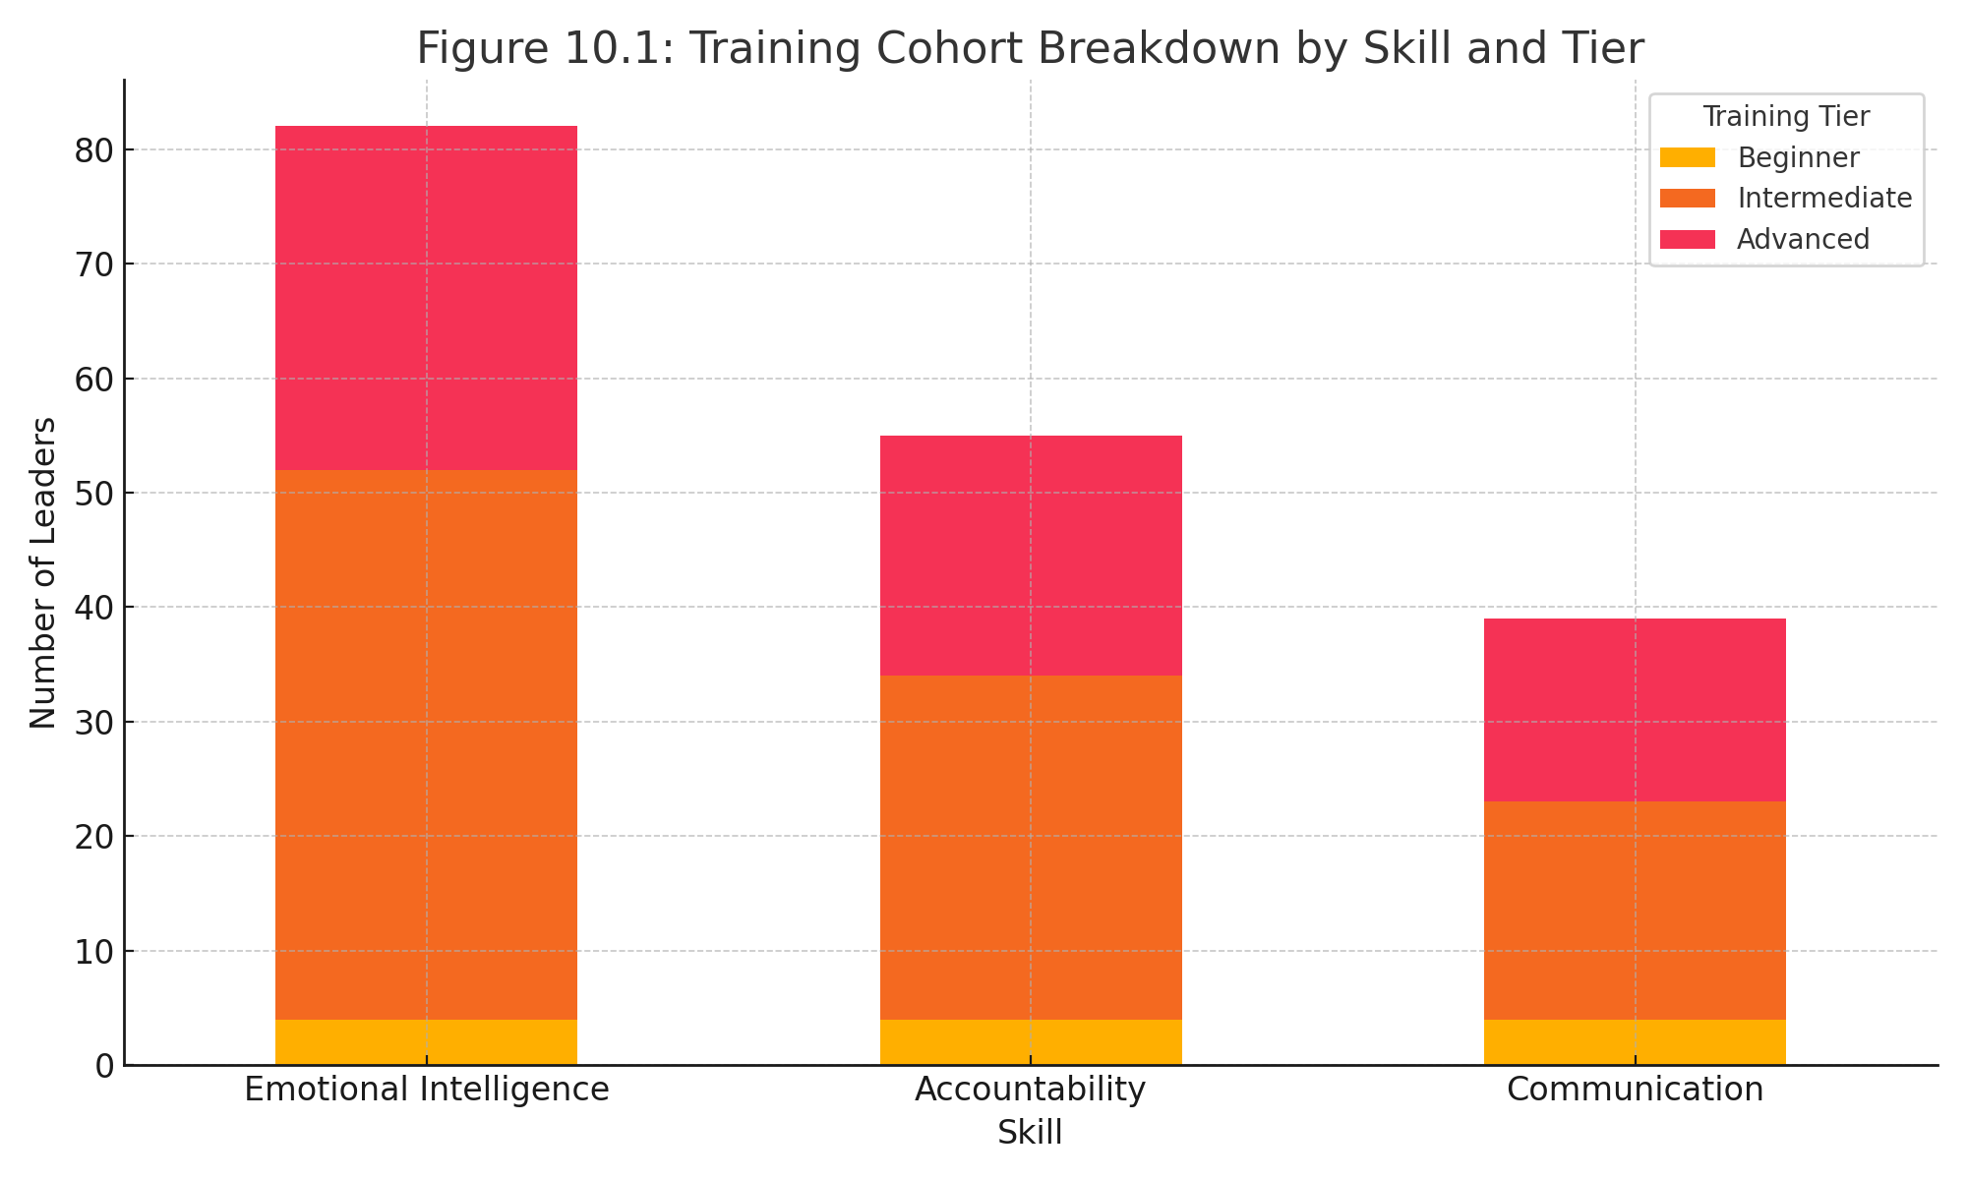

Appendix Figure A14**.** Full Table Breakdown in Appendix Table B8.

**Figure 10.1: Sample Training Cohort Breakdown by Skill and Tier***A visualization showing cohort sizes per skill and tier using a stacked bar chart (to be included in Appendix E)*

**Training Introduction Logic:**

The training roadmap introduced above should now be deployed in coordination with HR, focusing on:

* **Skill-Based Interventions:** Based on tiered needs (Beginner–Intermediate–Advanced) per skill cluster (see Appendix Report D3).
* **Skill Development:** Target EQ, Accountability, Communication, and Conflict Management with applied learning formats (coaching circles, scenario-based training, etc.).
* **Tracking Outcomes:** HR should use the training cluster file and dashboards to monitor cohort progress, training completion, and observed improvements via reassessment cycles.

#### 9.3.2.7 What Success Looks Like

If implemented correctly, this training model enables:

* High-volume yet personalized training rollout
* Skills development mapped to real business needs
* Seamless integration with existing dashboards and PDPs
* Live tracking of individual and cohort progress
* Structured reassessment logic for evaluating impact

**9.4.1 Line Manager Development**

Line managers are a critical lever for turning diagnostic insights into everyday leadership development. Their position between strategic oversight and operational execution uniquely equips them to reinforce expectations, model leadership standards, and sustain the momentum of the LDP initiative. To enable this, the program provides structured support across three pillars: **insight access, coaching capability, and mentorship integration**.

#### **9.4.1.1 Line Manager Reports: Insight to Action**

As part of the LDP implementation, each line manager received a **personalized report** summarizing the leadership profiles of their direct reports. These Line Manager Reports include:

* **Discovery-Tool Results**: Leadership Index Score (LIS), Emotional Intelligence (EQ), and Leadership Typology per team member
* **Skill Gap Summary**: Identification of which Key, Useful, and Supplemental skills fall below threshold
* **PDP Overview**: A synthesis of the top development priorities for each leader
* **Coaching Prompts**: Structured suggestions for follow-up, including 1:1 conversation starters, nudges, and peer coaching activities

The purpose of this tool is twofold:

* First, to **equip line managers with data-driven insights** that guide targeted coaching and support for their direct reports;
* Second, to **decentralize ownership of leadership development**, embedding accountability for people development into the organizational middle tier.

Sample Line Manager Report for Abbas Ali Ghuloom Haji provided in Appendix Report D1. For access to all Line Manager Reports, please refer to Appendix Reports D2.

#### **9.4.1.2 Train-the-Trainer Program: Building Coaching Capability**

To ensure that line managers are not only informed but empowered, a **Train-the-Trainer development module** is recommended for rollout. This course would enhance their ability to coach effectively using the diagnostic insights provided. Topics include:

* Core principles of behavioral coaching
* Best practices for performance-based feedback and development conversations
* How to support continuous skill reinforcement (especially for Intermediate-tier skill gaps)
* Monitoring progress and escalating needs to HR where appropriate

The goal is to **elevate line managers from passive recipients of reports to active development partners**—creating a sustainable and performance-aligned coaching culture.

#### **9.4.1.3 Mentorship Integration: A Development Multiplier**

Mentorship surfaced as a powerful development lever in the LDP. “Mentoring Leaders” were among the top performers, demonstrating high LIS, elevated EQ, and strong interpersonal skills. As such:

* Leaders with mentoring profiles (especially those scoring above 88.42) are prime candidates to serve as mentors
* Leaders with strategic styles (e.g., Visionary) or those facing certain challenges (e.g., Hands-Off) may benefit as mentees
* The integration of line managers and mentorship style leaders into Nesma’s mentorship framework—either as mentors or mentees—can amplify growth across critical soft skills like Listening, Conflict Resolution, Planning, and Empathy

This recommendation builds on IVY & Company’s existing partnership with Nesma & Partners, which has already successfully delivered **four mentorship cohorts**. Expanding mentorship access at the line manager level can reinforce development in core skill areas—particularly **Emotional Intelligence, Listening, Conflict Resolution, and Planning**—and increase overall leadership bench strength.

**9.5.1 Individual Level Development**

Individual leaders must own their development journeys. The Leadership Development Program (LDP) equips each participant with a personalized dashboard that delivers targeted learning tools and behavior-based insights. These resources are designed to support autonomous development while ensuring alignment with leadership readiness benchmarks.

**9.5.1.1 Personal Development Planning Tools**

Each leader’s dashboard includes a curated suite of development tools selected based on their diagnostic scores and leadership profiles. These include:

* Curated TED Talks, books, online courses, and thought leaders aligned to targeted competencies
* Nudges and self-reflection prompts to drive habit formation and increase self-awareness
* Learning recommendations mapped to each leader’s score band and tier (Beginner, Intermediate, Advanced)

All recommendations are powered by IVY & Company’s proprietary scoring engine, ensuring that content is not only relevant but also actionable and tailored to the demands of the leader’s role.

**9.5.1.2 Resource Trends Across the Cohort**

To guide HR’s future resource investment decisions, the program also aggregated the most frequently recommended learning resources across all personalized dashboards. These high-frequency tools signal common gaps and shared learning priorities across the leadership cohort.

One of the most recurring recommendations was **book-based learning.** The top titles most frequently assigned across the cohort centered on improving *communication*, fostering *accountability*, and enhancing *emotional* *intelligence*. These books emerged as cornerstone tools for foundational development and are likely to remain relevant as the program evolves.

**Figure 3.8: Most Frequently Recommended Books**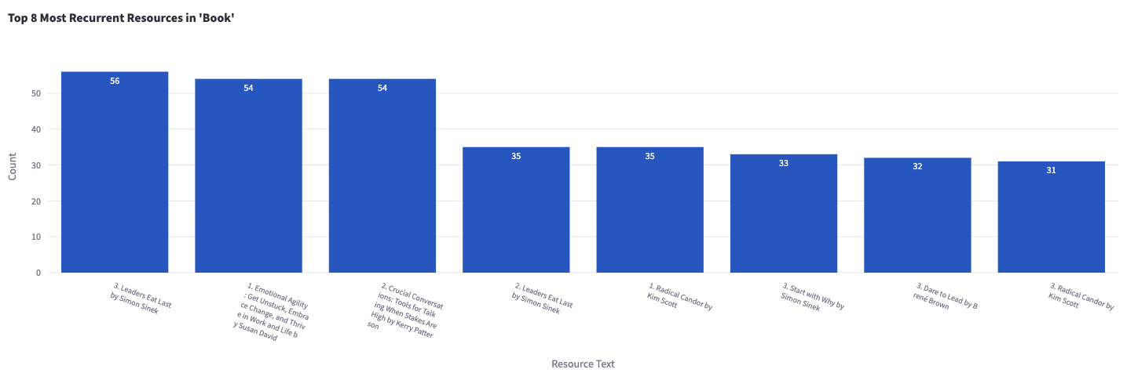

***Fig. 3.8.*** *presents the top 8 most frequently assigned book resources across all personalized development plans. These titles were selected based on alignment with individual skill gaps and represent recurring themes in leadership development such as communication, accountability, and emotional intelligence.* *Full view Appendix A10**.*

In terms of structured learning formats, **online courses** were widely recommended—particularly those from Coursera and LinkedIn Learning. These courses are used to build targeted competencies such as conflict resolution, adaptability, and leadership influence, making them effective tools for mid- to long-term development.

**Figure 3.9: Most Frequently Recommended Courses**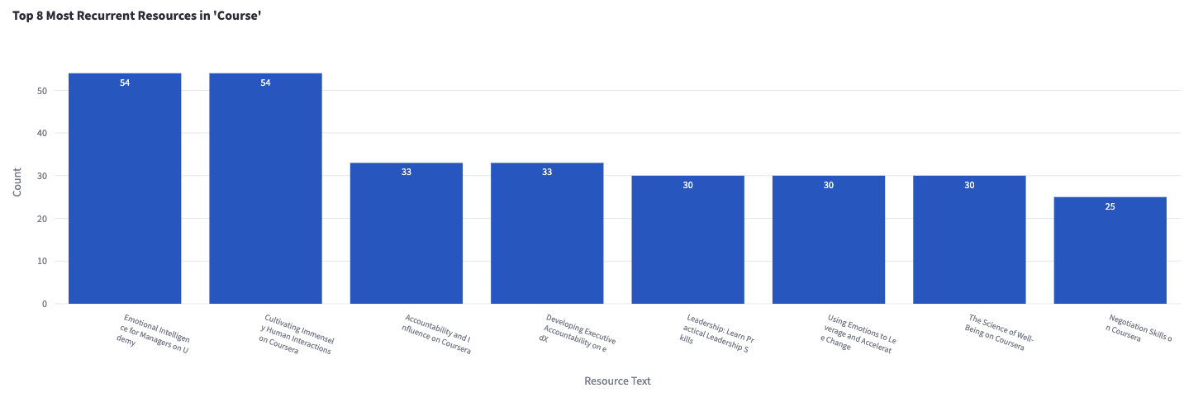

***Fig. 3.9.*** *highlights the most commonly assigned online courses across all leaders. These courses, sourced from platforms such as Coursera and LinkedIn Learning, were recommended based on performance in specific behavioral competencies and aim to support structured skill development.* *Full view Appendix A11**.*

In the domain of ongoing inspiration and reinforcement, **thought leadership via influencers** was embedded across dashboards. These influencers were selected for their focus on self-awareness, growth mindset, and people-centric leadership—reinforcing daily nudges and reflective learning.

**Figure 3.10: Most Frequently Recommended Influencers**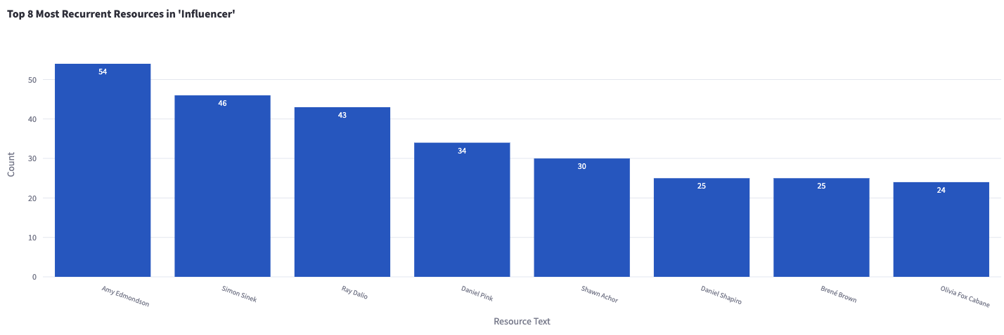

***Fig. 3.10.*** *shows the top influencer recommendations provided to leaders as part of their personalized development plans. These individuals were selected for their thought leadership in areas such as self-awareness, motivation, and people-centered leadership practices.* *Full view Appendix A12**.*

#### Finally, video-based talks, especially TED Talks and similar formats, were assigned frequently to complement traditional learning modes. These talks were chosen to expose leaders to new perspectives, challenge existing thinking patterns, and promote change through reflection and relatability.

#### **Figure 3.11: Most Frequently Recommended Talks**

***Fig. 3.11.*** *displays the most frequently suggested educational talks—primarily TED Talks and similar content—used to supplement development plans with fresh perspectives on leadership, productivity, and change.* *Full view Appendix A13**.*

## Phase 10: Key Learning Points & Way Forward

The Leadership Development Program (LDP) pilot provided critical insight into both leadership capability and program implementation at Nesma & Partners. This final phase consolidates key challenges, successful learnings, and proposed next steps to sustain and scale impact.

### 10.1 Key Challenges and Learnings

#### 10.1.1 Key Challenges

* **Cancellation of Face-to-Face Workshop Delivery:** The original implementation plan included a live, instructor-led workshop to launch the program. Due to logistical constraints and the scale of participation, this component was replaced with a pre-recorded video format. While this ensured an accessible and flexible format for all 100 participants, the absence of a live session reduced opportunities for interactive engagement, immediate feedback, and real-time alignment.
* **Engagement Variability Due to Self-Paced Format:** Participation timelines varied significantly across the cohort. Although the self-paced model accommodated different schedules, some leaders required multiple reminders to complete program steps, including the discovery tools. This inconsistency introduced delays in downstream processes such as dashboard generation and report consolidation.
* **Timeline Extensions from Cascading Delays:** Dependencies between phases—specifically the prerequisite completion of the LDP Workshop and Discovery-Tools prior to dashboard creation—meant that delays by individual participants affected the program’s overall timeline. The flexible delivery model, while necessary, extended the originally anticipated duration of key phases.

#### 10.1.2 Key Learnings

The LDP pilot surfaced several key success factors critical to future program scalability and organizational impact:

* **Process Optimization Enabled Scalable Execution:** Multiple components—including dashboards, PDP engines, engagement tracking, and communication workflows—were successfully automated. This plug-and-play structure allows for rapid replication in future cohorts without rebuilding infrastructure.
* **Role-Specific Customization Enhances Validity:** The job-clustered dashboard architecture, designed in Phase 1, enabled role-relevant benchmarking and avoided misleading cross-role comparisons. This enhanced both accuracy of insights and precision of development recommendations, improving credibility with leaders.
* **Personalized Development Planning Drives Engagement:** The Personal Development Plans (PDPs)—which included curated resources, nudges, and tiered learning paths—emerged as a top-rated component. These tools translated diagnostic insight into daily learning, embedding development into each leader’s workflow.
* **Leadership Typology Informs Strategic Design:** Insights from the MANSSA typology revealed strong patterns. “Mentoring Leaders” outperformed on LIS and EQ, reinforcing the value of mentorship traits. These findings validated the logic behind typology-matched mentorship and succession planning frameworks.
* **Pre-Recorded Delivery Ensured Consistency:** Replacing live sessions with asynchronous video workshops enabled 100% participation without logistical constraints. QR validation confirmed engagement and ensured all leaders received a uniform foundation of understanding.
* **Top-Down Endorsement and Review Linkages Increase Compliance:** Program completion rates improved when endorsed by senior VPs and connected to performance review cycles. Framing LDP participation as a leadership expectation rather than an optional opportunity increased accountability and follow-through.
* **Face-to-Face Moments Are Critical for Leadership Buy-In:** Despite success with asynchronous delivery, in-person engagement points (e.g., coaching or review meetings) significantly boosted leader activation. Live touchpoints should be retained as strategic inflection points for deeper buy-in and culture reinforcement.
* **Micro-Level Flexibility Built Trust:** Every component—from discovery-tool instructions to dashboard terminology—was iteratively refined based on leader and HR feedback. This responsiveness helped build stakeholder trust and ensured the program felt culturally aligned.

### 10.2 Strategic Recommendations and Next Steps

The Leadership Development Program (LDP) pilot provided critical insight not only into Nesma & Partners’ current leadership capabilities but also into how future development initiatives can be structured for long-term success. This final phase captures the most important lessons learned during implementation and outlines strategic recommendations to sustain and evolve the program’s impact.

To capitalize on the momentum of the pilot and strengthen future impact, the following strategic steps are recommended:

#### 10.2.1 Institutionalize the LDP as a Recurring Cycle

Rather than treating the LDP as a one-off intervention, codify it as a recurring 12–18 month leadership development cycle. Each cycle can include:

* Diagnostics (Discovery-Tools)
* Development Planning (PDP)
* Training Execution
* Reassessment and Progress Review

This ensures continuous leadership growth and aligns with evolving organizational needs.

#### 10.2.2 Expand to Additional Leaders

The current program has demonstrated both scalability and depth of insight. We recommend launching the next cohort with 400+ leaders, focusing on:

* Role-critical populations
* Clusters with high training load or EQ gaps
* Emerging talent and succession candidates
* Female Leaders for gender related analysis and insights

#### 10.2.3 Build an Outcomes Dashboard

Develop a centralized training outcomes dashboard to track improvements, cohort-wide trends, and training completion. This dashboard can provide visibility for HR and executives, enabling agile course correction and targeted reinforcement.

#### 10.2.4 Reinforce and Scale Mentorship Infrastructure

Expand Nesma’s mentorship model using LDP Insights. Leverage high-LIS and Mentoring Leaders as mentors and assign Visionary/Hands-Off leaders as mentees to promote EQ and soft skills.

#### 10.2.5 Invest in Line Manager Capability

Equip line managers with training and coaching skills to support ongoing development. The “Train-the-Trainer” model ensures development is reinforced on the ground and creates a cascade effect across leadership levels.

#### 10.2.6 Prepare for Reassessment and Optimization

Schedule Discovery-Tool reassessments 6–12 months post-training to evaluate impact, update dashboards, and adjust individual PDPs. This closes the learning loop and allows HR to measure ROI on development initiatives. Use these insights to iterate future waves of the program.

## Phase 11: HR Toolkit Implementation

### 11.1 What Is the Leadership Competency Viewer?

*A Smart Decision-Support Tool for Leadership Development*

The **Leadership Competency Viewer** is an AI-enabled, interactive analytics platform developed to empower HR, leadership teams, and learning & development specialists at Nesma & Partners with real-time, actionable insights. Built on the full data architecture of the Leadership Development Program (LDP), the tool bridges diagnostic precision with user-friendly exploration—allowing anyone, regardless of technical background, to evaluate leadership effectiveness and drive talent decisions.

The Viewer combines:

* Real-time dashboards with visual analytics
* A built-in AI chat assistant trained on the full LDP methodology
* Smart filtering and drill-down views
* Personalized development tracking per leader

The tool eliminates traditional pain points in leadership development—such as fragmented data and manual report interpretation—by offering a centralized decision-support system.

### 11.2 What Problem Does It Solve?

Leadership development is often hindered by:

* Leadership development efforts are frequently slowed by:
* Fragmented tracking across spreadsheets, dashboards, and reports
* Limited pattern visibility across roles, clusters, and cohorts
* Time-consuming manual analysis and reporting
* Minimal access to data-driven insights for non-technical users

The **Leadership Competency Viewer** solves these pain points by offering:

* A unified competency dataset
* Automated visualizations with dynamic filters
* Built-in assistant that understands leadership data and reporting logic
* Interactive views into every leader’s development profile and skill gaps

### 11.3 Core Capabilities

#### **11.3.1 Filter and Focus Instantly**

Quickly segment data by:

* Dashboard group (e.g., D2, D4)
* Leadership typology (e.g., Mentoring, Visionary)
* Position or job role
* Individual leader name  
   All charts, summaries, and assistant answers update automatically based on filter selections.

#### 11.3.2 AI Assistant + Chart-Level Insights

The tool includes a sidebar AI assistant trained on:

* All structured LDP data
* The full Final Report (methodology, terminology, metrics, etc.)

You can ask questions like:

* “Who are the top 5 leaders by LIS?”
* “What does the report say about mentoring typologies?”
* “Which cluster has the highest training load?”
* “Explain the LDNA concept again.”

Every chart also includes a **“Generate Insights”** button. When clicked, the AI provides tailored summaries based on your current filters—explaining what the data means and how it should be interpreted.

#### 11.3.3 Leadership Data Visualizations

Interactive sections include:

* **Leadership Overview Table** – summary of every leader, role, typology, and dashboard link
* **LDNA Visualization** – composite view of LIS, EQ, style, engagement, skill depth, and training load
* **Fit Composition** – donut chart of role fit across the cohort
* **LIS and EQ Distributions** – histograms to analyze score dispersion
* **Typology & Polar Charts** – style breakdowns and performance trends by typology
* **Top Performers by Skill** – high-scorers across key areas
* **Skill Strength/Weakness Maps** – identify systemic trends and red flags
* **Leader Radar Charts** – view how one leader compares to their cohort across all skills

#### 11.3.4 Skills Gap & Development Recommendations

* **Training Clusters by Skill** – map of which skill areas need reinforcement
* **Resource Recommender** – leader-specific learning content mapped to development needs
* **Resource Library** – filterable by skill, format (video, book, article), and level (Beginner/Intermediate/Advanced)
* **Training Load Dashboard** – total flagged skills and number of resources per leader

#### **11.3.5 How to Use the Tool**

* **Step 1: Launch the Tool**Access the Leadership Competency Viewer via the provided [URL](https://mlfinal-7bnkw3eebcjkiszxpvpmnk.streamlit.app/).
* **Step 2: Adjust Filters (Left Sidebar)**Narrow down by dashboard cluster, typology, position, or specific leader.
* **Step 3: Use the AI Assistant**Ask plain-language questions related to data, insights, or report content. The assistant will auto-classify the query and return a complete response.
* **Step 4: Click “Generate Insights”**For any chart, use the built-in AI explainer to understand the chart in context—including trends, outliers, and action items.
* **Step 5: Explore the Dashboard**Navigate through visualizations covering LIS, EQ, styles, gaps, and recommendations.
* **Step 6: Deep-Dive into an Individual**Select a leader and access their personalized profile—PDP, typology, training load, and resource plan.
* **Step 7: Get Help Anytime**Use the chat assistant to explore the data, interpret the report, or troubleshoot any metric—no technical skills needed.

#### **11.4 Final Note**

The LDP pilot cohort has proven that when data, personalized development, and strategic enablement converge, leadership development can be both scalable and deeply human. By continuing to evolve the program with data-driven decision-making, Nesma & Partners is not only investing in individual leaders—but building a resilient, people-centered leadership culture equipped for the future.

Looking forward to reviewing these results together and aligning on the most strategic next steps.

The Ivy & Company Team

## Citations

Goleman, D. (1998). *What makes a leader?* Harvard Business Review, 76(6), 93–102. <https://dme.childrenshospital.org/wp-content/uploads/2019/06/What-makes-a-Leader-HBR.pdf>

Cherniss, C. (2010). *Emotional intelligence: Toward clarification of a concept*. Industrial and Organizational Psychology, 3(2), 110–126.<https://www.researchgate.net/publication/229545635_Emotional_Intelligence_Toward_Clarification_of_a_Concept>

Boyatzis, R. E., Goleman, D., & Rhee, K. (2000). *Clustering competence in emotional intelligence: Insights from the Emotional Competence Inventory (ECI)*. In R. Bar-On & J. D. A. Parker (Eds.), *The Handbook of Emotional Intelligence* (pp. 343–362). Jossey-Bass. <https://www.eiconsortium.org/pdf/eci_acticle.pdf>

Korn Ferry. (n.d.). *Korn Ferry Leadership Architect™*. <https://www.kornferry.com/capabilities/talent-suite-hcm-software/korn-ferry-assess/leadership-architect>

Hay Group. (2016). *Hay job evaluation methodology – An overview*. People Centre. <https://peoplecentre.wordpress.com/2016/07/05/hay-job-evaluation-methodology-an-overview/>

Peoplebox. (2022). Lominger competencies: The ultimate guide. <https://www.peoplebox.ai/blog/lominger-competencies/>

#### **Appendix**

#### **Appendix A: Figures**

##### **Figure A1: Automated Dashboard - Leader Skill Distribution View**

##### **Figure A2: PDP Interface - Onboarding Explanation**

##### **Figure A3: PDP Interface - Areas of Development & Tools to Support**

##### **Figure A4: Box Plot of EQ by Dashboard**

##### **Figure A5: Leadership Index Score (LIS) Distribution**



##### **Figure A6: LIS Distribution Across Leadership Typologies**

##### **Figure A7: Average Soft Skill Scored by Leadership Typologies**

##### **Figure A8: Top 10 Strongest Skills by Average Score**

##### **Figure A9: Leaders by LIS Band and Key Skill Performance**



##### **Figure A10: Most Frequently Recommended Books**

##### **Figure A11: Most Frequently Recommended Courses**

##### **Figure A12: Most Frequently Recommended Influencers**

##### **Figure A13: Most Frequently Recommended Talks**

##### 

##### **Figure A14: Training Cohort Breakdown by Skill and Tier**

##### Figure A15: Training Buckets per Skill and Proficiency Level



##### Figure A16: Top 7 Weakest Skills by Average Score



#### **Appendix B: Tables**

##### **Table B1: LDNA Composition Breakdown**

| **LDNA Component** | **Description** |
| --- | --- |
| **Leadership Index Score (LIS)** | Composite readiness metric integrating EQ and skill proficiency |
| **Emotional Intelligence (EQ)** | Standalone indicator of interpersonal adaptability and emotional regulation |
| **Soft Skill Depth** | Aggregated scores from Key, Useful, and Supplemental skill tiers |
| **Leadership Style** | Typology-based insight into natural behavioral patterns (e.g., Visionary, Mentoring) |
| **Engagement Behavior** | Participation metrics from program milestones and behavioral touchpoints |
| **Training Load** | Number and depth of flagged development needs |

##### **Table B2: Organizational LDNA Profile**

| **LDNA Domain** | **Organizational Mean** | **Interpretation** |
| --- | --- | --- |
| LIS | 77.87 | Cohort readiness above baseline; majority are role-aligned |
| EQ | 71.4 | Developmental; 48 in intermediate tier (see below) |
| Skill Depth | 74.2 (avg. across all tiers) | Strong in Key Skills; executional gaps (e.g., Communication, Accountability) persist |
| Leadership Style | 35.3% Mentoring | High people-centricity; strategic asset for mentorship and coaching culture |
| Engagement | 54.3% | Based on workshop completion, speed of completion of discovery-tools, reminders needed. |
| Training Load | Avg. 6.8 flagged skills | Majority fall in Intermediate tier (172), indicating refinement needs over remediation |

##### **Table B3: Engagement Calculator & Weightings**

| **Component** | **Description** | **Max Points** | **Weight (%)** |
| --- | --- | --- | --- |
| QR Code Scanned | Whether the Leader scanned the code at the end of the workshop video | 25 | 25% |
| Discovery-Tools Completed | Completion of both MANSSA and MEIQ Discovery-Tools | 25 | 25% |
| Speed of Completion | Normalized by days taken from launch to completion | 20 | 20% |
| Proactive Communication | Leader-initiated emails (2 pts/email, max 10 pts) | 10 | 10% |
| Reminders Received | Deductions applied for each reminder sent (-1 point per reminder) | -10 | Up to -10% |
| Line Manager Escalation | Deduction if Line Manager escalation was needed due to inactivity | -5 | -5% |

##### **Table B4: LDNA by Dashboard**

| **Dashboard Cluster** | **Key LDNA Insights** |
| --- | --- |
| **D1: Executive and Senior Leadership** | No leaders from this dashboard type were in the program. |
| **D2 – Executive Operations** | High EQ and LIS with strong resilience and strategic execution; minor gaps in collaboration, conflict resolution, and change agility may hinder cross-functional cohesion. |
| **D3 – Senior Management - Operations and Logistics** | Strong execution and project delivery; underperformance in resilience, coaching, and interpersonal domains; development needed in emotional regulation and mentoring for long-term leadership effectiveness. |
| **D4 – Logistics & Site Management** | Strong task execution and innovation; gaps in emotional regulation, supportiveness, and negotiation hinder cross-team alignment and adaptive leadership. |
| **D5 – Engineering** | Strong technical and Key Skills proficiency; however, gaps exist in team-building, interpersonal clarity, and communication. Beneficial leadership behaviors like Risk Management and Teamwork are underdeveloped. Needs support in people operations and behavioral resilience. |
| **D6 - Procurement & Supply Chain Management** | Strong execution in operational adaptability and data-driven thinking; gaps in communication, accountability, and cross-functional collaboration require attention to improve alignment and supplier engagement. |
| **D7 – Corporate Quality Assurance and Control** | Strong execution in quality control and problem-solving; gaps in emotional intelligence and conflict management may limit feedback flow and team openness |
| **D8 – Health, Safety, and Security** | Strength in structured communication and compliance; underperformance in conflict management, monitoring, and negotiation impacts ability to respond effectively to safety incidents and maintain team alignment under pressure. |
| **D9 – Corporate Governance** | Significant behavioral misalignment driven by low EQ and weak communication; critical gaps in emotional self-awareness and adaptability threaten governance consistency. Requires targeted support in interpersonal clarity and structured leadership routines. |
| **D10 – Financial and Risk Control** | Strong financial oversight and data interpretation capabilities; gaps in negotiation, conflict management, and risk adaptability may undermine strategic consensus and hinder collaborative financial leadership. |
| **D11 – Strategy & Business Development** | High LIS and strong strategic execution, but behavioral misalignment exists. Visionary leaders show gaps in innovation, emotional intelligence, and calculated risk-taking—traits essential for agile, forward-looking leadership in dynamic environments. |
| **D12 – Corporate Communications and Training** | Strong in team leadership and goal-setting; however, critical gaps in emotional self-awareness, communication clarity, and listening skills may hinder internal messaging and engagement effectiveness. |
| **D13 – Administrative and Support Services** | Strong delivery in problem-solving and team coordination; however, leadership effectiveness may be limited by gaps in conflict resolution, emotional intelligence, and performance monitoring. Development in interpersonal and evaluation skills is recommended to enhance administrative efficiency and collaboration. |

#### Table 3.6: Leaders Requiring Development Support

| **Name** | **Job Position** | **LIS** |
| --- | --- | --- |
| EL Chami Hassan | Security Manager | 65.2710 |
| Taha Anwar | Sr. Planning Manager | 68.553 |
| Alolaywi Mohammed | Training & Development Manager | 68.454 |
| Abu Ahmadeh Ali | Construction Manager-Mep | 64.3160 |
| Owida Mohamed | Commissioning Manager | 68.925 |
| Bshara Ayham | Construction Manager-Civil | 64.8815 |
| Alsultan Salsabeel | Communications Manager | 64.3030 |
| Mohammad Hallab | Site Manager - Civil | 67.2335 |
| Alamoais Shihab | Director - Internal Audit | 67.546 |
| Alabdullah Qassem | Government Relation Manager | 65.1750 |
| Alsamail Hassan | Security Manager | 66.9930 |
| Hefni Fathy Yosry | Project Manager-Civil | 57.0325 |

#### 

##### **Table B6: Skill-Gap Threshold**

| **Skill Tier** | **Score Threshold** | **Definition** |
| --- | --- | --- |
| Key Skills | ≥ 85% | Mission-critical skills required for role success |
| Useful Skills | ≥ 70% | Enable day-to-day team performance and productivity |
| Supplemental Skills | ≥ 60% | Broaden leadership effectiveness, not essential to role |
| Emotional Intelligence (EQ) | n/a | Modeled as a standalone behavioral domain |

##### **Table B7: Skill Development Tier**

| **Development Tier** | **Score Range** |
| --- | --- |
| Beginner | 0–59 |
| Intermediate | 60–74 |
| Advanced | 75–84 |

##### **Table B8: Most Common Skill Gaps (By # of Leaders Needing Training)**

| **Skill** | **Total Leaders Needing Training** | **Beginner** | **Intermediate** | **Advanced** |
| --- | --- | --- | --- | --- |
| Emotional Intelligence (EQ) | 82 | 4 | 48 | 30 |
| Accountability | 55 | 4 | 30 | 21 |
| Communication | 39 | 4 | 19 | 16 |
| Change Management | 28 | 6 | 16 | 6 |

##### **Table B9: Typology Breakdown (Cohort Distribution)**

| **Typology** | **% of Leaders** |
| --- | --- |
| The Mentoring Leader | 35.3% |
| The Go-Getter Leader | 27.1% |
| The Visionary Leader | 14.1% |
| The Middle-of-the-Road | 10.6% |
| The Hands-Off Leader | 5.88% |
| The Parental Leader | 5.88% |
| The Permissive Leader | 1.18% |

##### 

##### Table B10: EQ Development Distribution

| **Development Tier** | **# of Leaders** | **Interpretation** |
| --- | --- | --- |
| Beginner (0–59%) | 4 | Very limited emotional self-regulation or awareness; foundational development needed |
| Intermediate (60–74%) | 48 | Functional EQ skills present, but require further refinement under pressure or ambiguity |
| Advanced (75–84%) | 30 | Solid EQ capabilities, with room for optimization in complex or high-stakes environments |

##### Table B11: Expanded LDNA

| **LDNA Component (Included in Current Scope)** | **Expanded LDNA Framework Elements (Excluded from current scope)** |
| --- | --- |
| 1 - Leadership Index Score (LIS) | 7- Mentorship Readiness |
| 2 - Emotional Intelligence (EQ) | 8- Strength of the Development Culture |
| 3 - Average Soft Skill Score | 9- Recognition Practices |
| 4 - Leadership Typology(style) | 10 -Retention Trends |
| 5 - Engagement Behavior | 11 -Alignment of Hiring Practices with Desired Leadership Traits |
| 6 - Development Areas per Leader | 12 -Alignment of Onboarding Practices with Desired Leadership Traits |
|  | 13 -Leadership Style Fit |
|  | 14 - Leader/Employee Cultural Fit |

#### **Appendix C: Streamlit**

[Access the Streamlit Interface Here](https://mlfinal-7bnkw3eebcjkiszxpvpmnk.streamlit.app/)

#### **Appendix D: Reports and Spreadsheets**

##### **Report D1: Sample Line Manager Report**

[Sample Line Manager Report - Abbas Ali Ghuloom Haji](https://drive.google.com/file/d/1ht8O0-gO8eXbTNgsjp6T3H6SQwqzxcgP/view?usp=drive_link)

##### **Reports D2: All Line Manager Reports**

[LDP Line Manager Reports](https://drive.google.com/drive/folders/1-Wo3dGbNAiEbmp21y8NToV4wAYJPmuyv?usp=drive_link)

##### **Report D3: Training Cluster Spreadsheet**

[Training Cluster Spreadsheet](https://docs.google.com/spreadsheets/d/1g8vtma1iU3kcy-evmtmJ026bcqNnUDQ9BTwB4FKm1TM/edit?usp=drive_link)

##### **Report D4: Mentorship Matching Infrastructure**

[Mentorship Matching Infrastructure](https://docs.google.com/document/d/1BLz9vskUx8Txpg0IfuKkPw66ZOQevY7eA7K2m2mWbjU/edit?usp=sharing)